**Name: Naresh Thelagama**

Email: [nareshdt99@gmail.com](mailto:nareshdt99@gmail.com)

Mobile No: 9885857229

Industry Grade Project 1 (Building a CI/CD Pipeline for a Retail Company)

Git repository: https://github.com/nareshdt99/mainproject

=============================================================================  
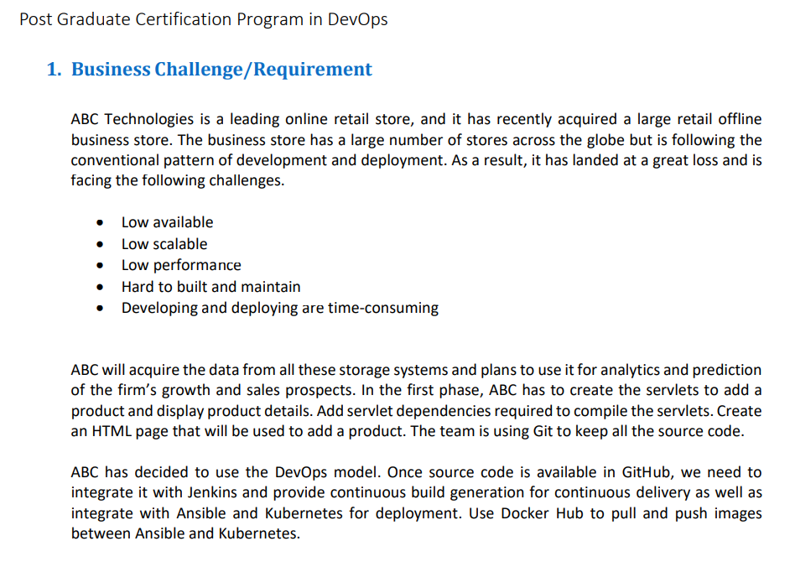

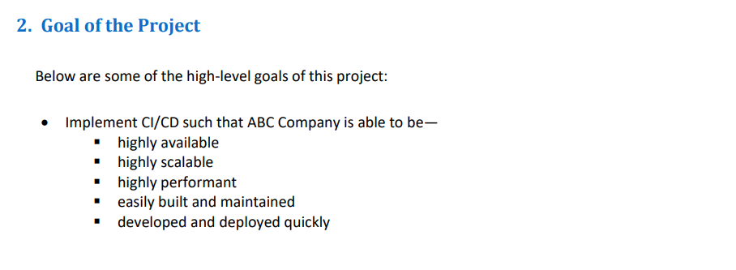

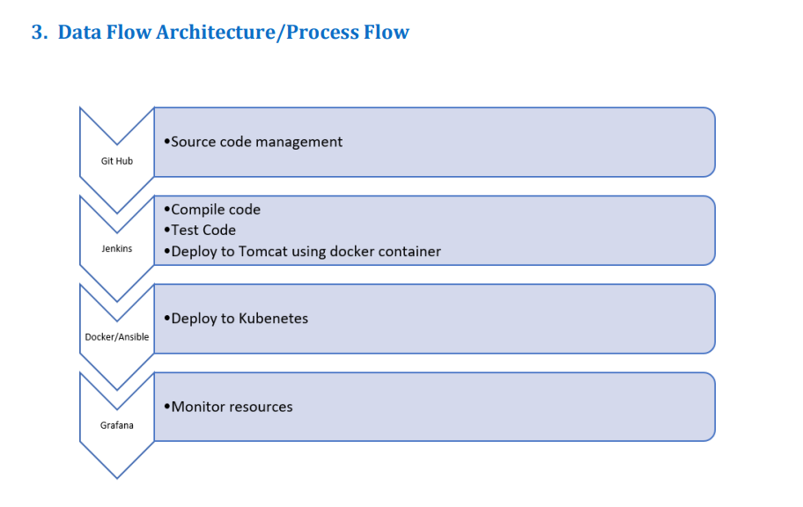

**Task 1:   
 Clone the project from the GitHub link shared in resources to your   
 local machine. Build the code using Maven commands.  
  
Step1:** Create java project repository on GitHub.  
   
GitHub link: <https://github.com/nareshdt99/mainproject>   
  
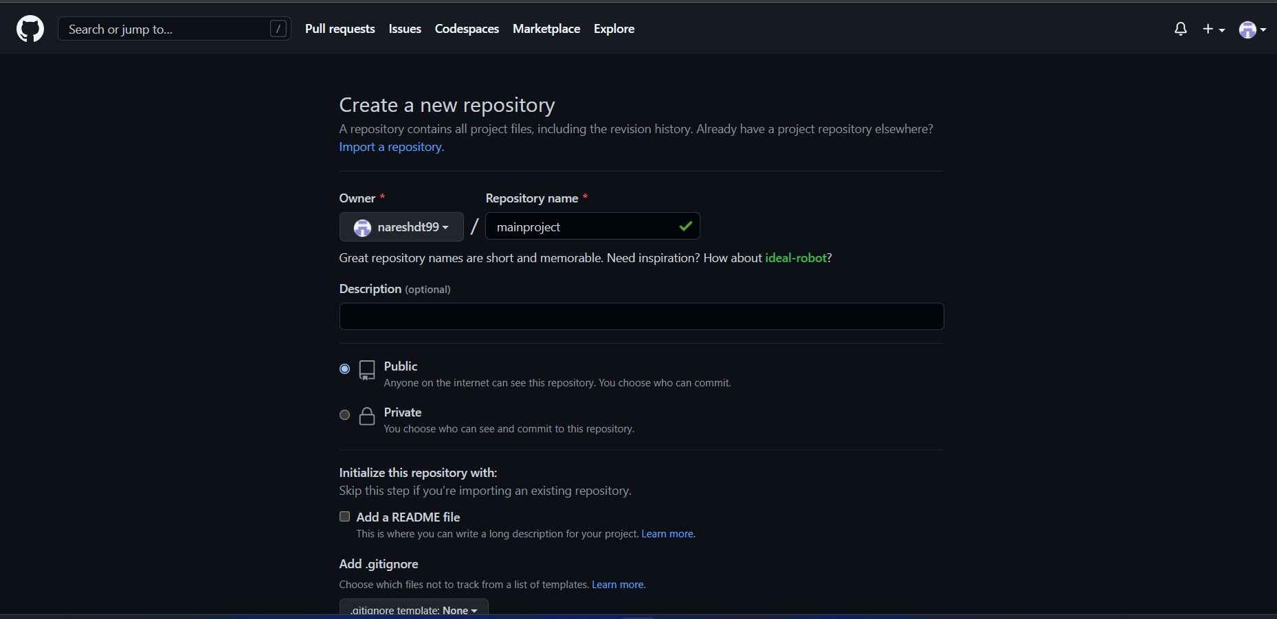  
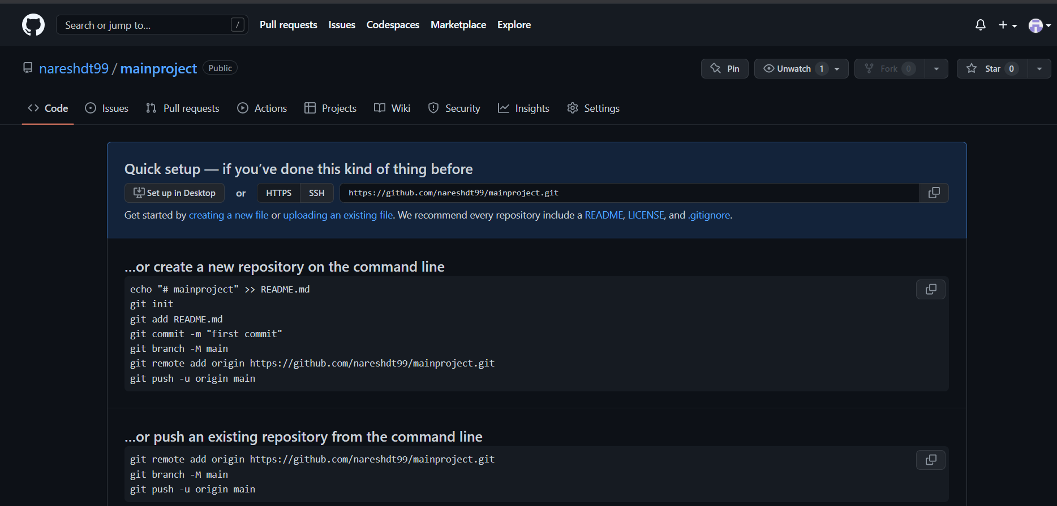  
Step 2: Clone repository.  
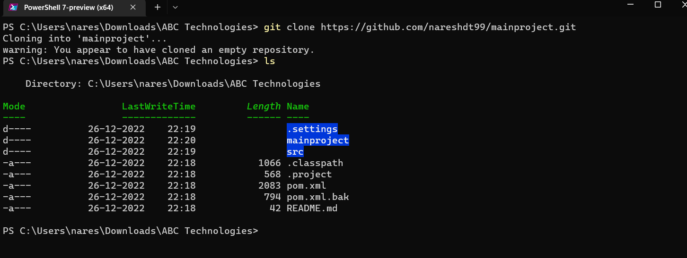  
Step 3: Add code, commit and push to the repository.  
  
git init  
git add README.md  
git commit -m "first commit"  
git branch -M main  
git remote add origin https://github.com/nareshdt99/mainproject.git  
git push -u origin main  
  
  
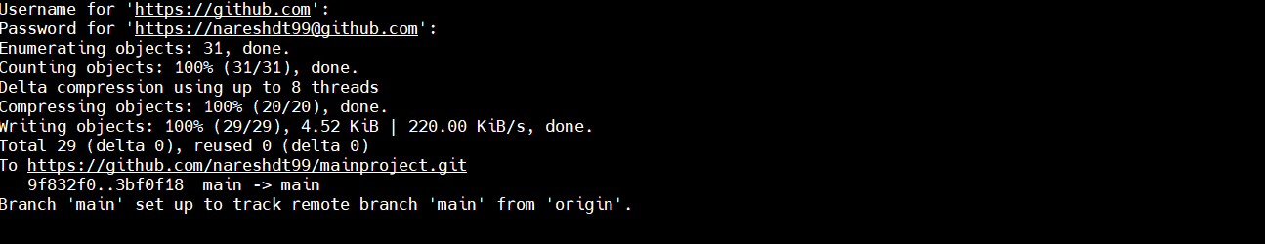  
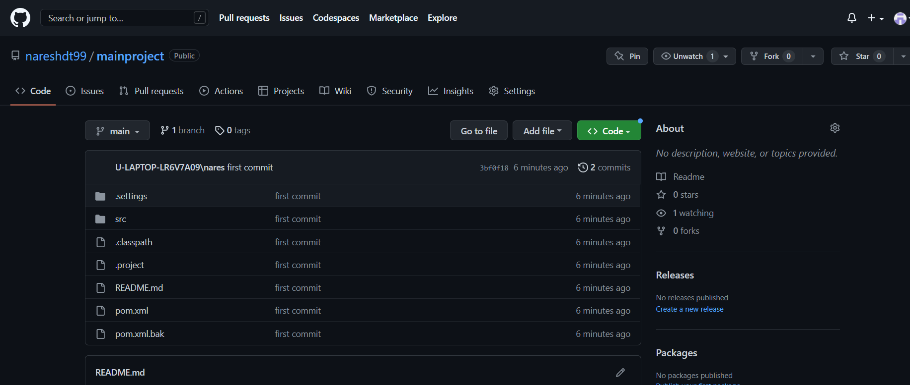 **using Edureka cloud Labs, cloning application from git and building using maven.  
  
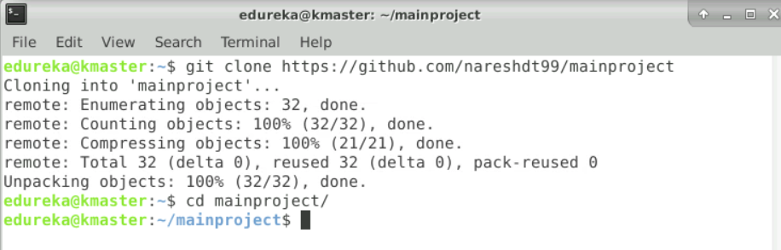  
  
  
  
  
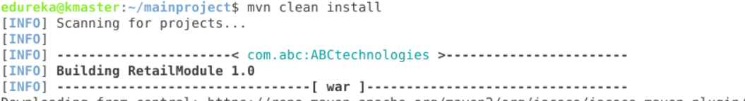**

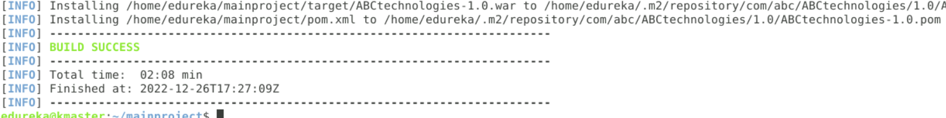  
  
 **Task 2:   
Set up the Git repository and push the source code. Then, log in to Jenkins.**Login to Jenkins:  
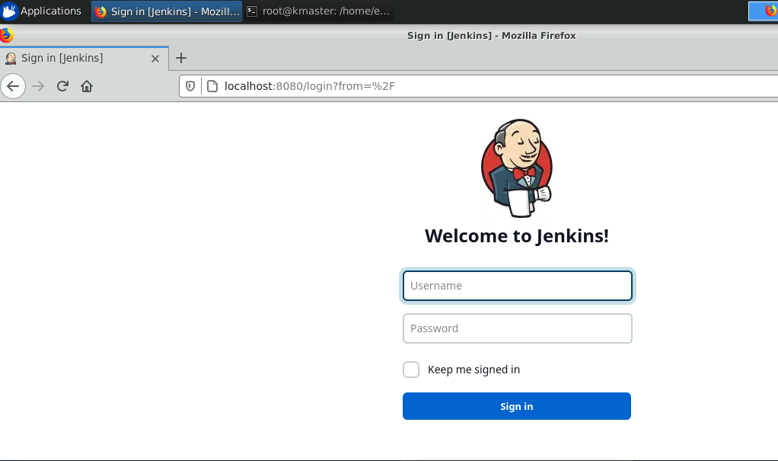  
 **2.1.1 Creating a job for compiling source code:**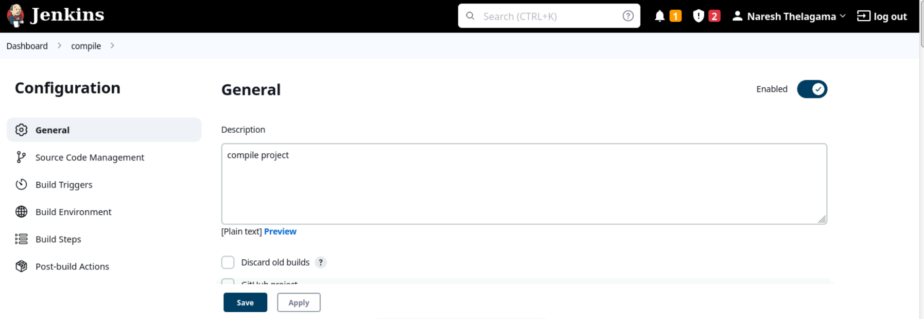 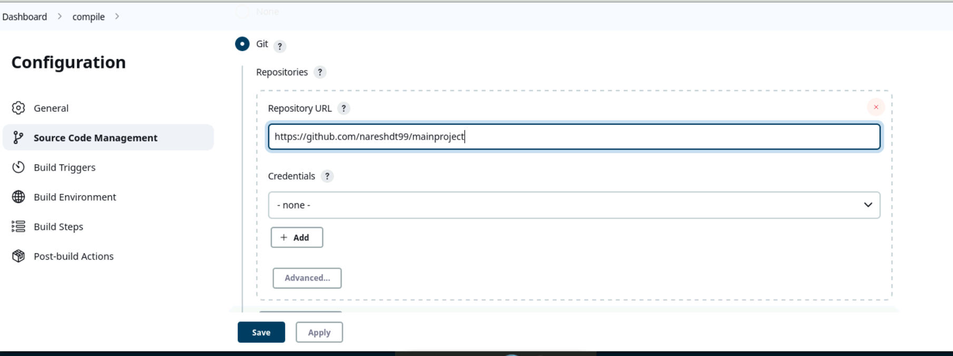

Console output after running the compile job:  
  
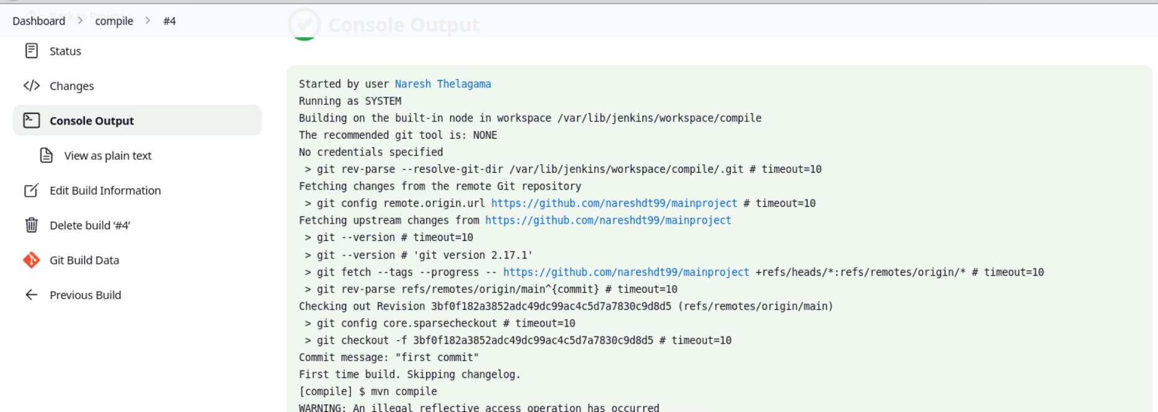

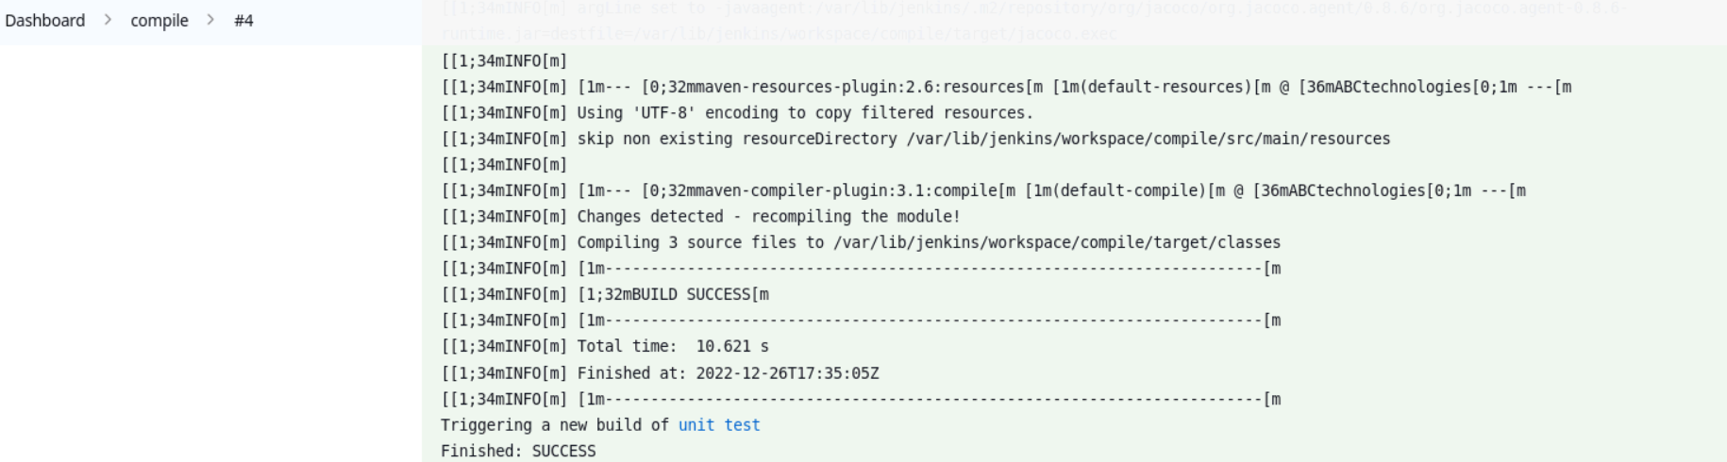  
  
2.1.2 Creating a job for testing source code:  
  
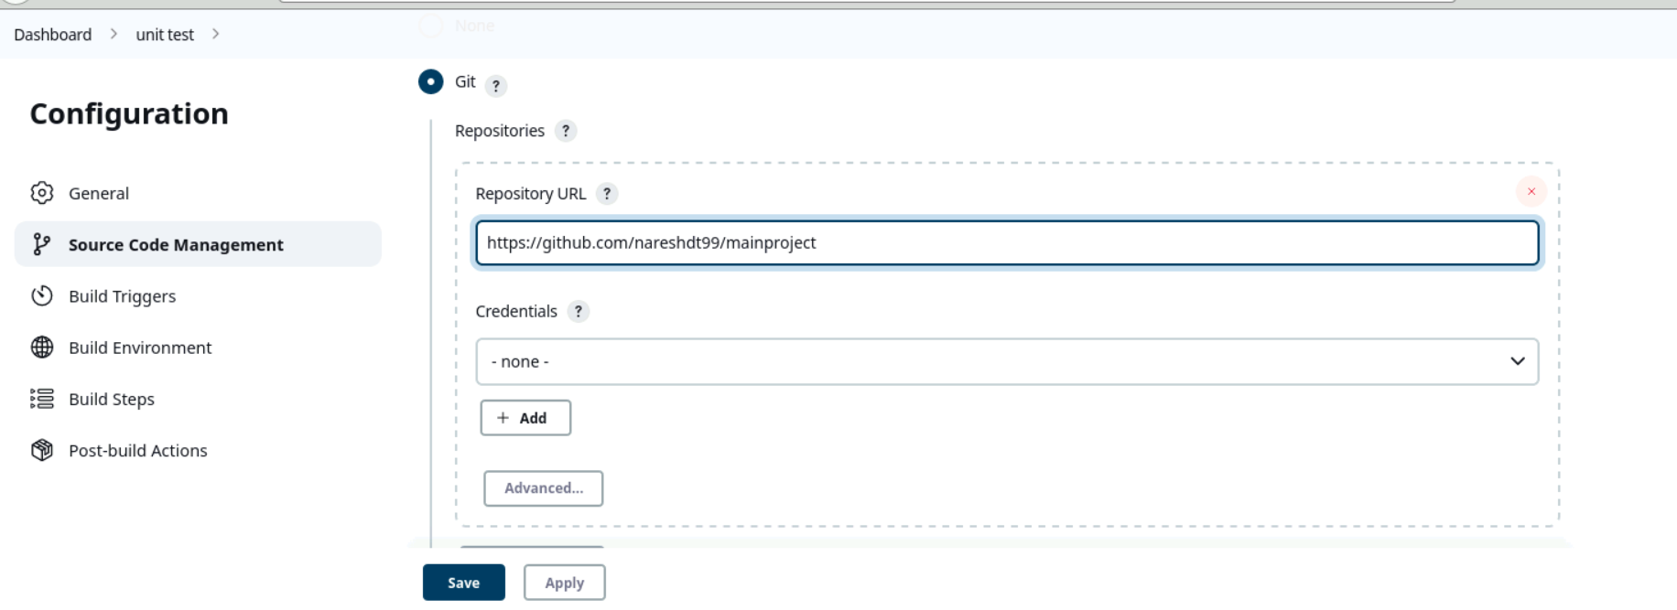  
  
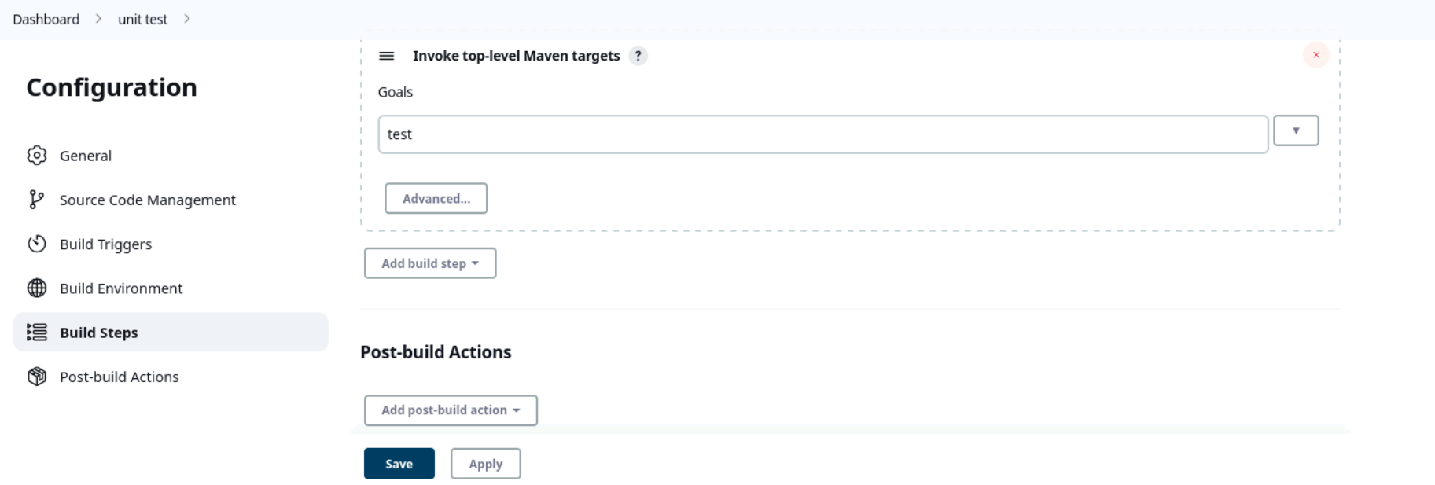  
  
**Console output after running the test job.**

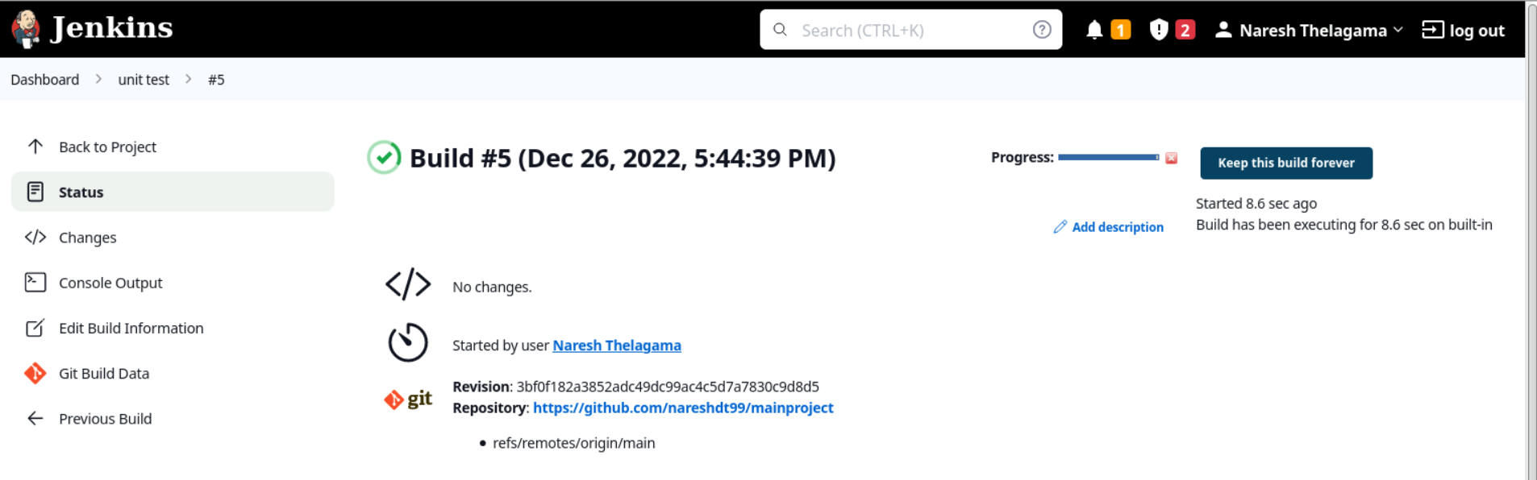

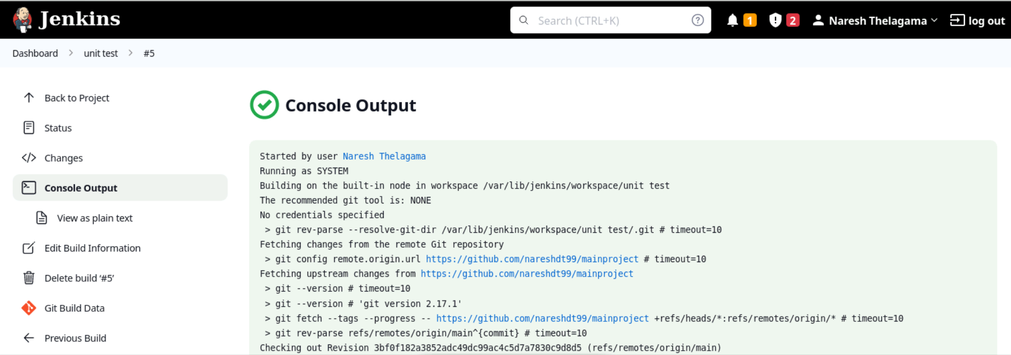

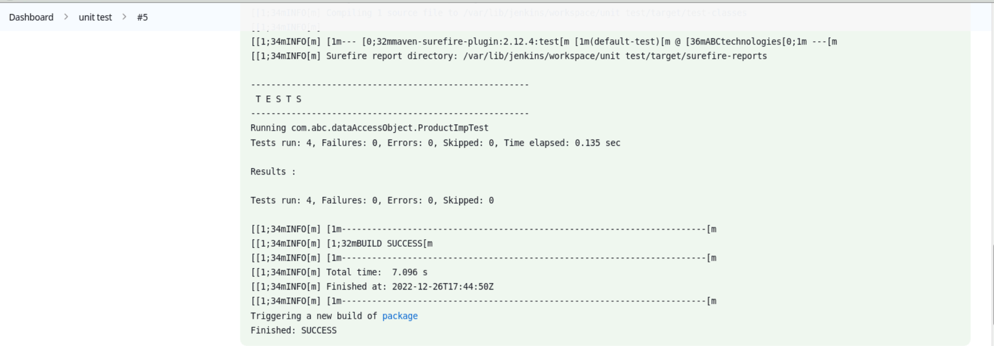

2.1.3 Creating a job for packaging source code

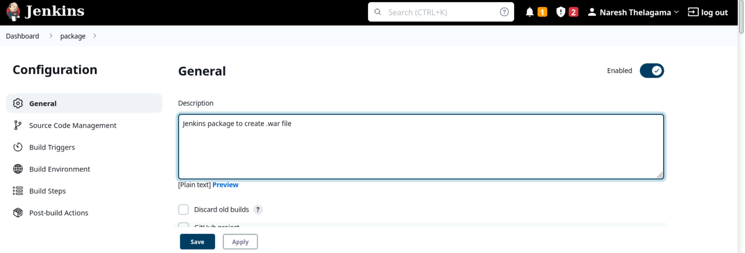

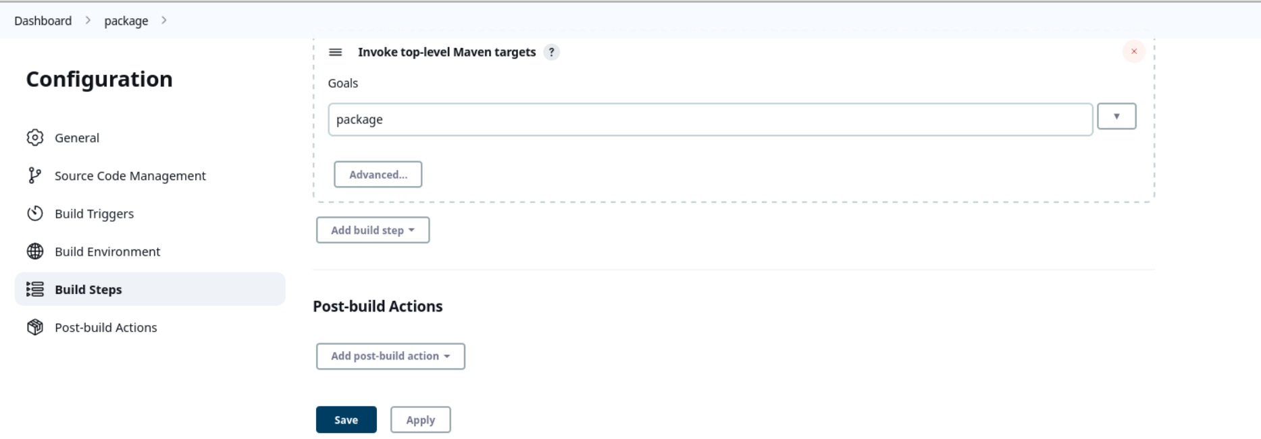

Console output after running package job.  
  
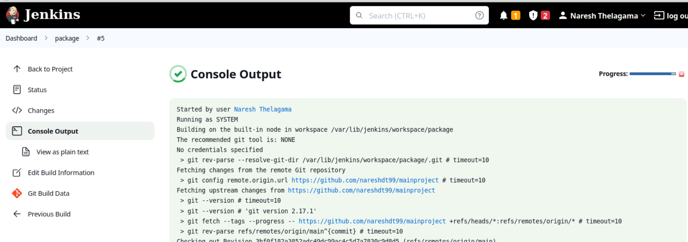

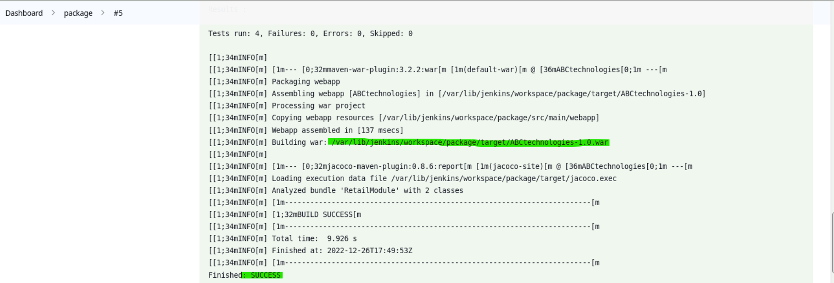  
  
Jenkins Dashboard with compile, testing, package of source code  
  
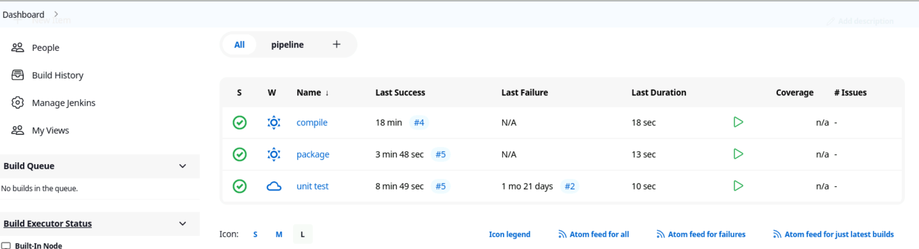

2.2 CI/CD pipeline to execute the jobs created in step 1

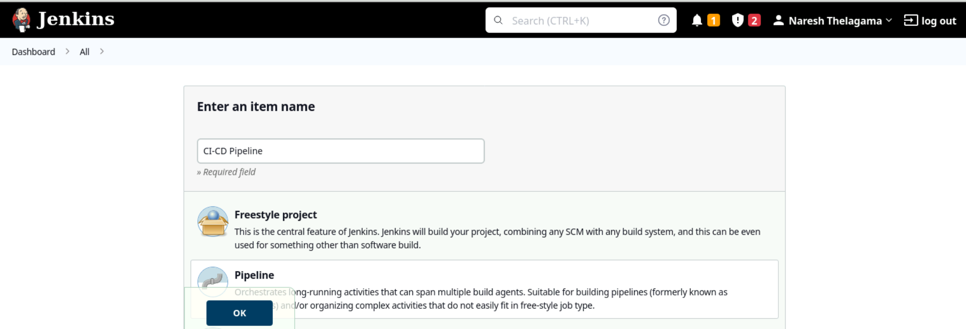

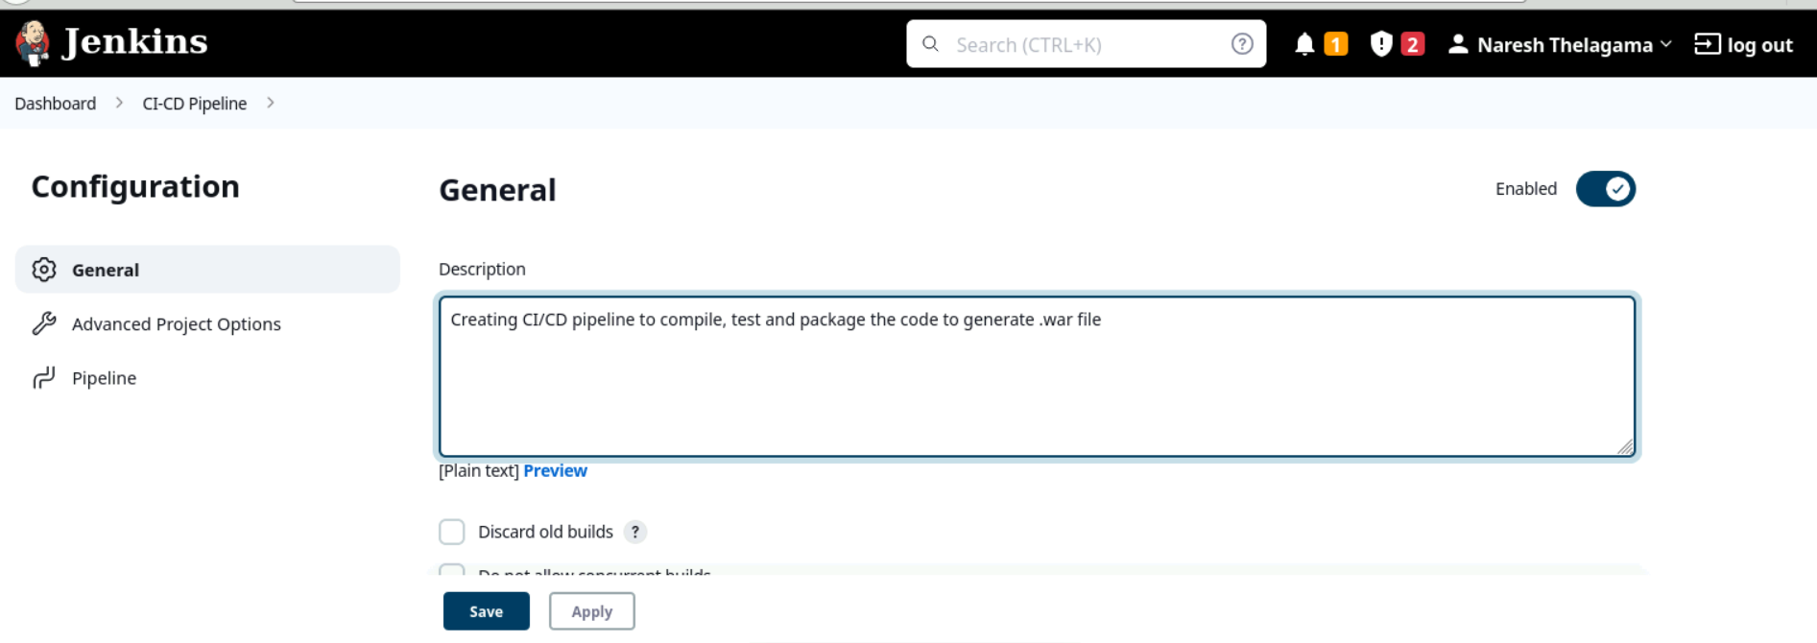

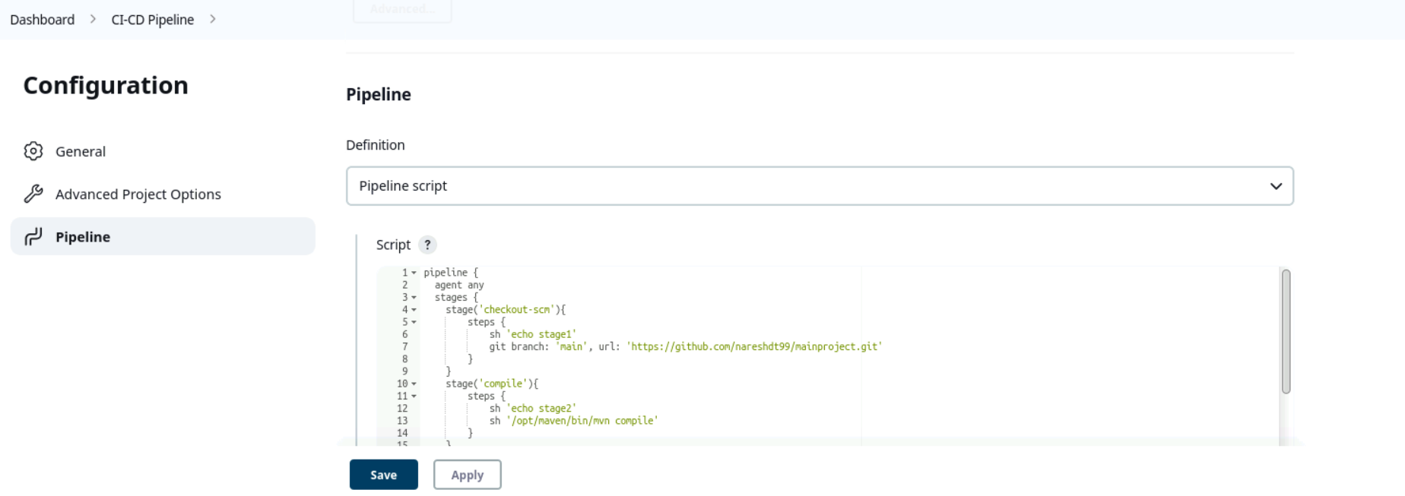

Pipeline script:  
pipeline {

agent any

stages {

stage('checkout-scm'){

steps {

sh 'echo stage1'

git branch: 'main', url: 'https://github.com/nareshdt99/mainproject.git'

}

}

stage('compile'){

steps {

sh 'echo stage2'

sh '/opt/maven/bin/mvn compile'

}

}

stage('test'){

steps {

sh 'echo stage3'

sh '/opt/maven/bin/mvn test'

}

}

stage('package'){

steps {

sh 'echo stage4'

sh '/opt/maven/bin/mvn package'

}

}

}

}

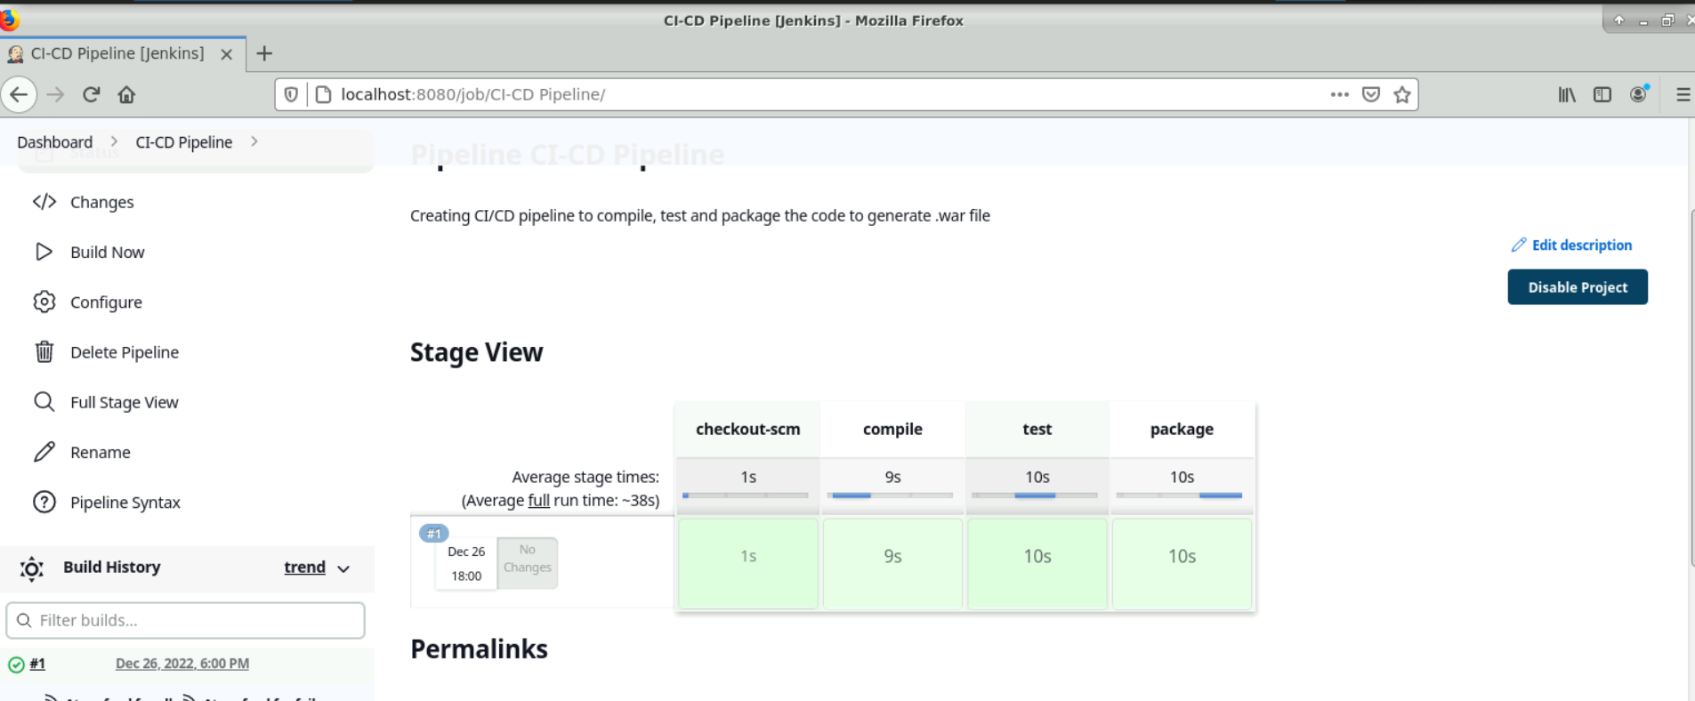  
  
console output:

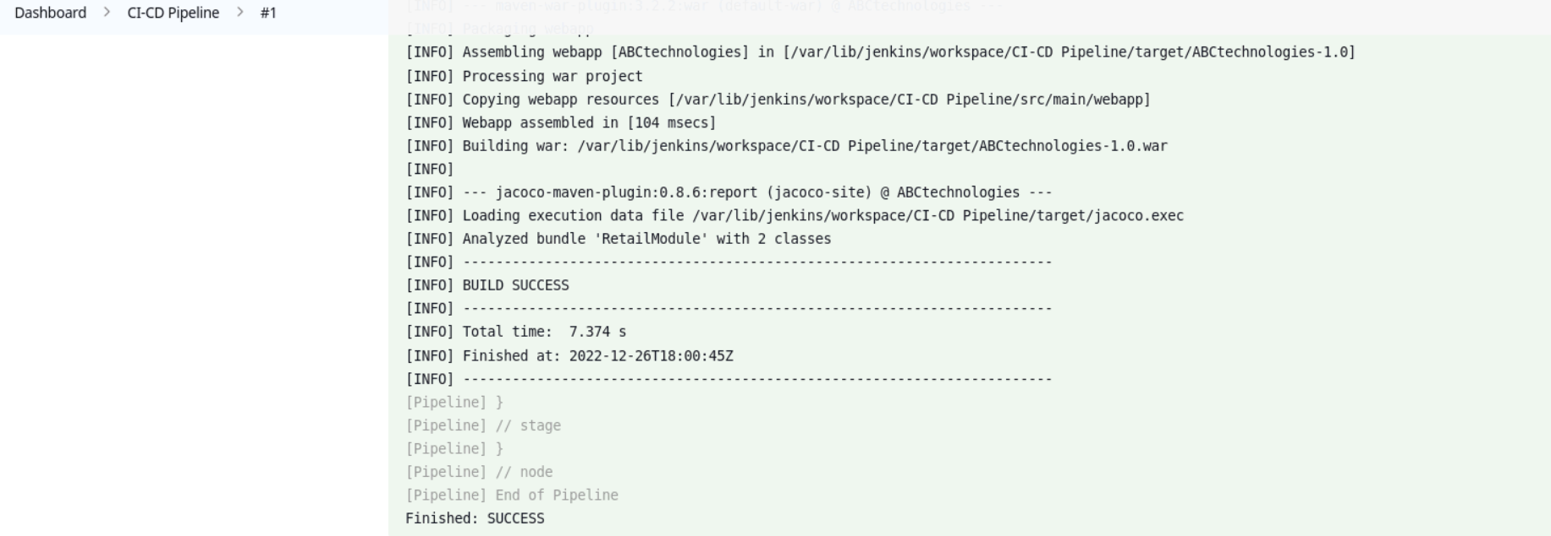

2.3 Setting up a master-slave node to distribute the tasks in the pipeline.  
 To add a slave node, go to Manage Jenkins and click on Manage Nodes and Clouds.   
  
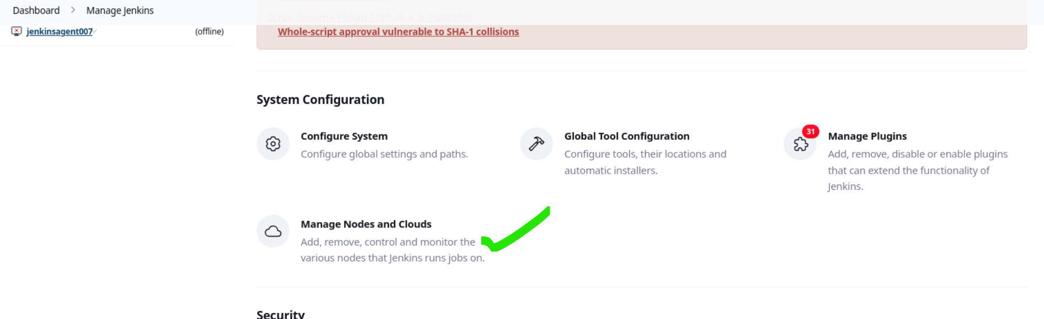

Added Jenkins agent: jenkinsagent007

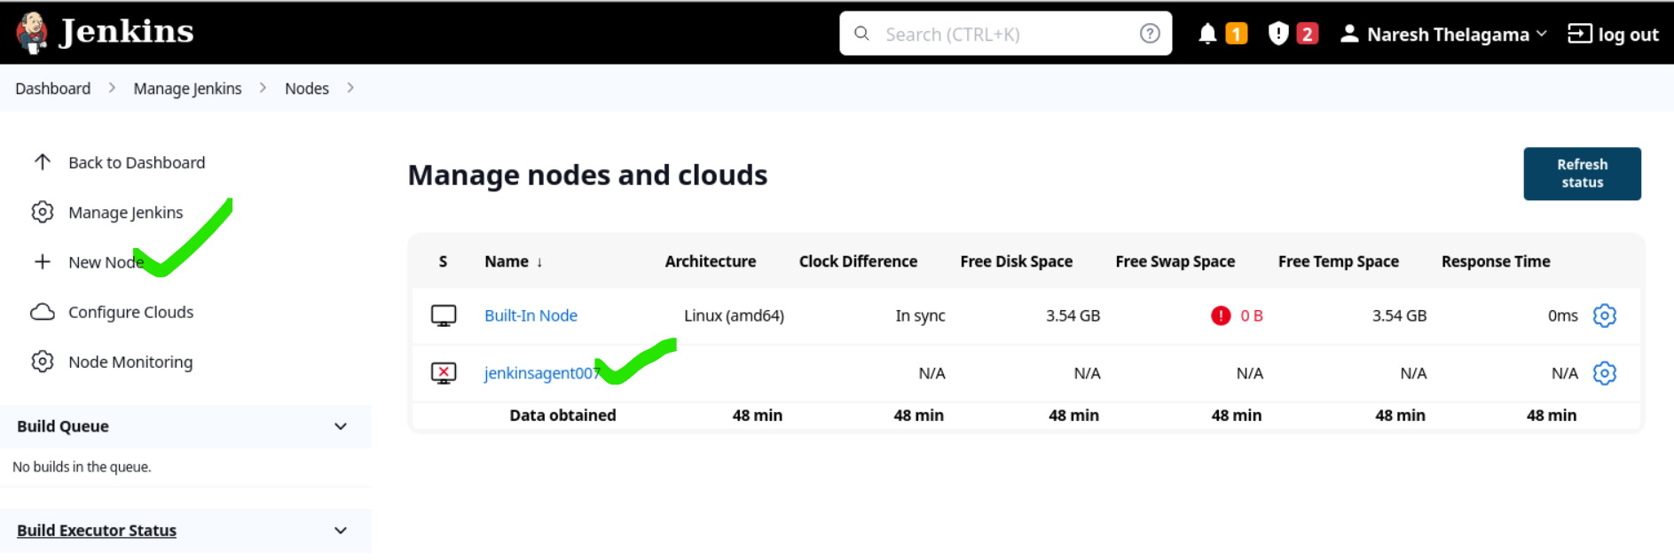

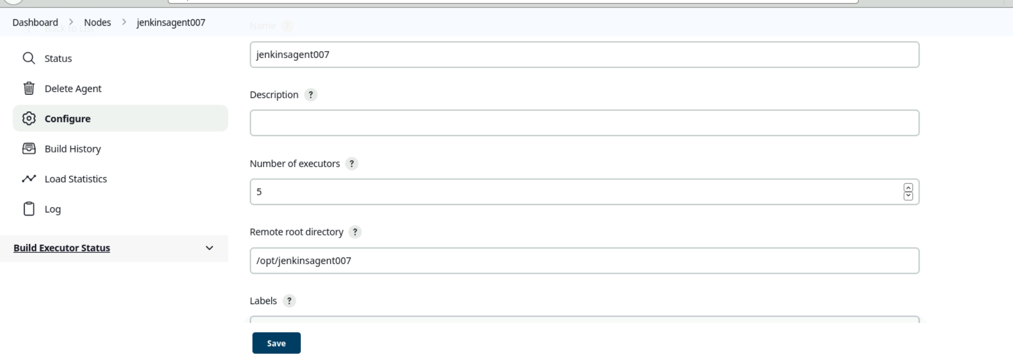

copy agent.jar file to slave vm  
  
location: /opt/jenkinsagent007  
Run from agent command line:

curl -sO <http://172.31.13.114:8080/jnlpJars/agent.jar>

java -jar agent.jar -jnlpUrl http://172.31.13.114:8080/computer/jenkinsagent007/jenkins-agent.jnlp -secret 50b7e9019f86b0b609124355710a99ee38766bef2c4c990f50811bdd72905bae -workDir "/opt/jenkinsagent007"

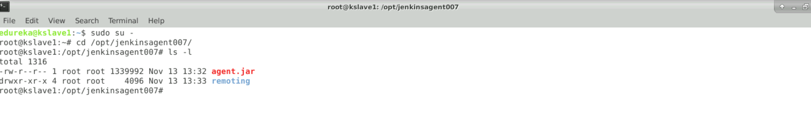

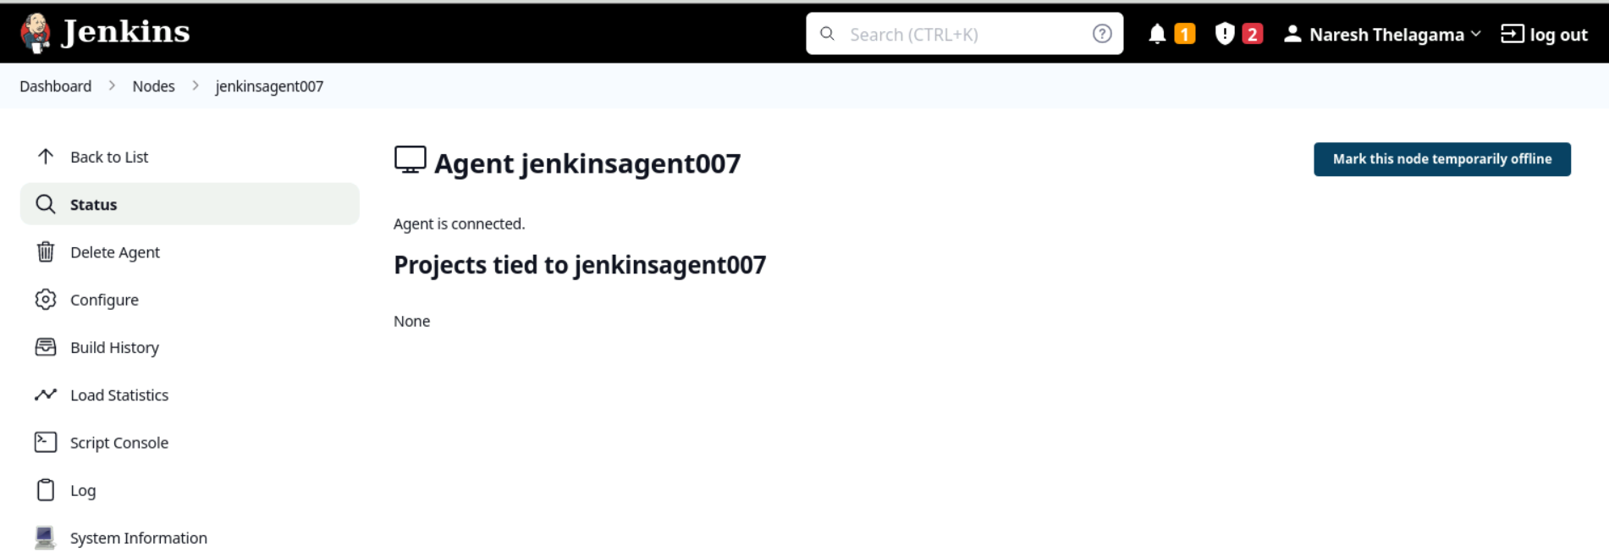

Running CI/CD pipeline on agent node (jenkinsagent007):

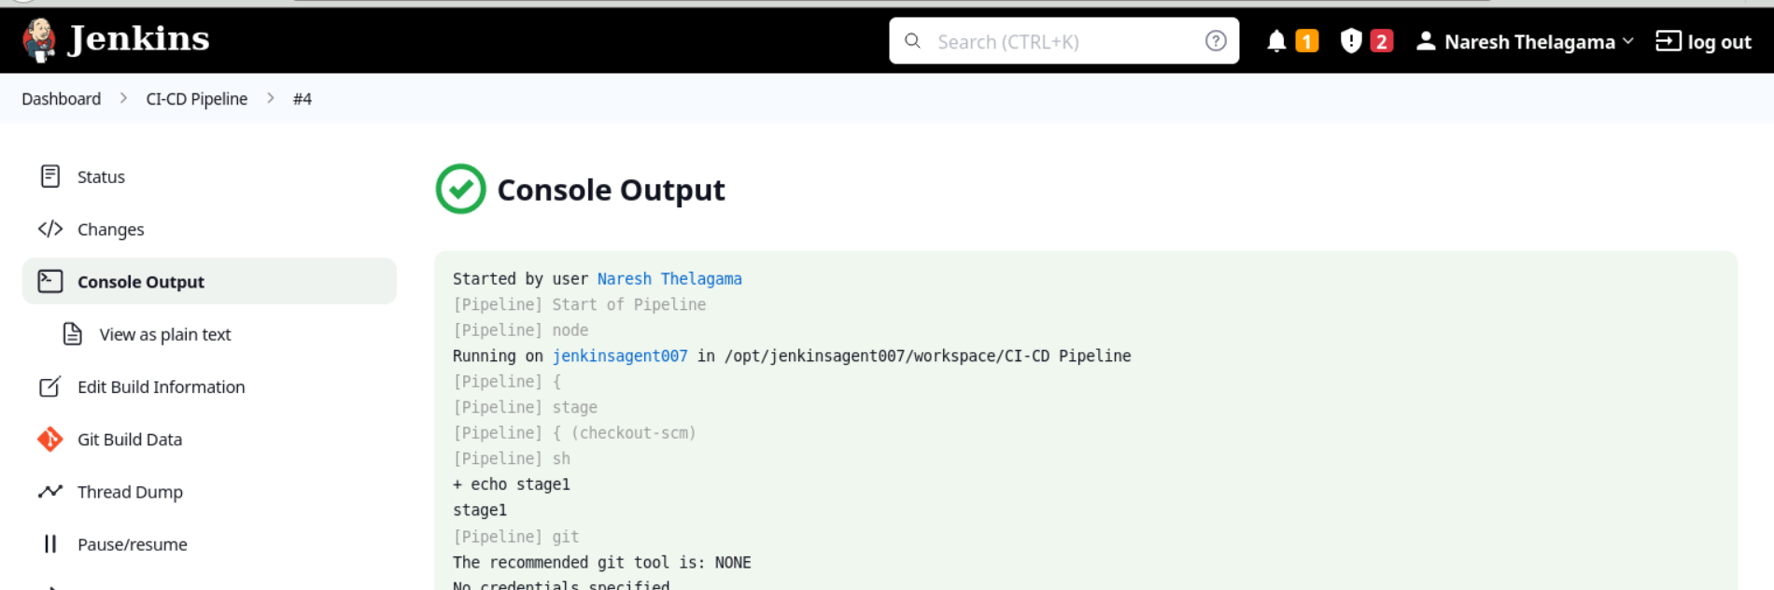  
  
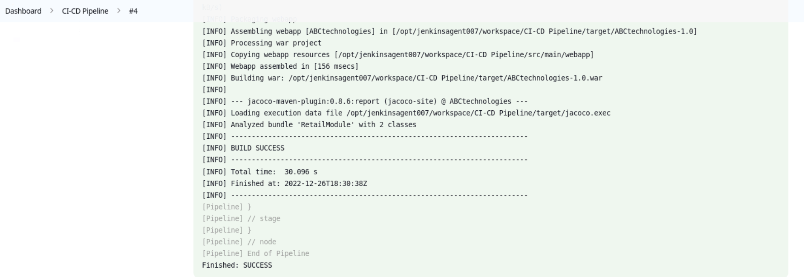

# Task 3: Part 1: Write a Docker file. Create an Image and container on the Docker host.

Write a Docker file. Create an Image and container on the Docker host. Integrate docker host with Jenkins. Create CI/CD job on Jenkins to build and deploy on a container.

1. Enhance the package job created in step 1 of task 2 to create a docker image.

2. In the Docker image, add code to move the war file to the Tomcat server and build the image.  
  
Dockerfile: https://github.com/nareshdt99/mainproject/blob/main/Dockerfile  
FROM tomcat:8.5.50  
WORKDIR /usr/local/tomcat/webapps/  
COPY */ABCtechnologies-1.0.war /usr/local/tomcat/webapps/  
EXPOSE 8090  
CMD ["/usr/local/tomcat/bin/catalina.sh", "run"  
  
extending Jenkins script to create docker image using Dockerfile and deploy on Tomcat server  
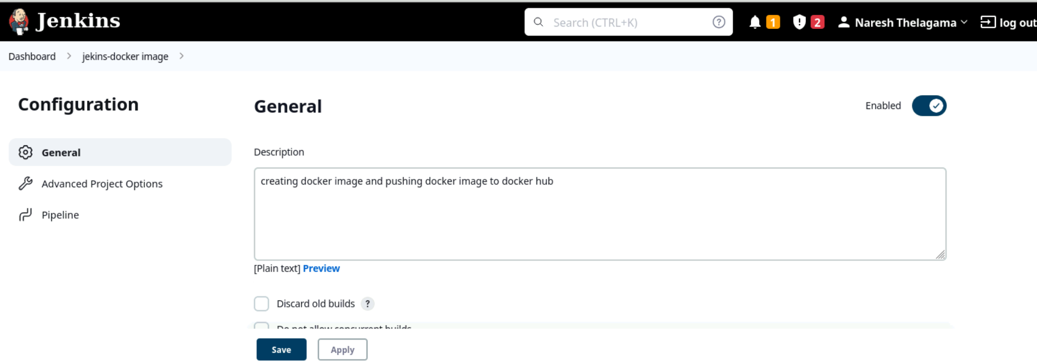

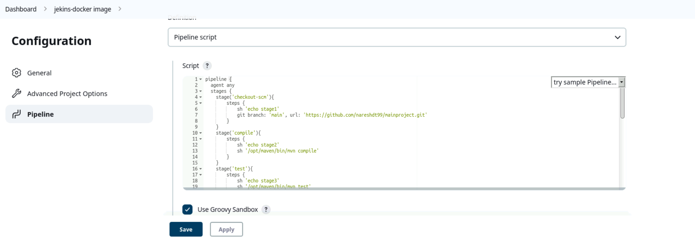

Script: <https://github.com/nareshdt99/mainproject/blob/main/Jenkinsfile>  
  
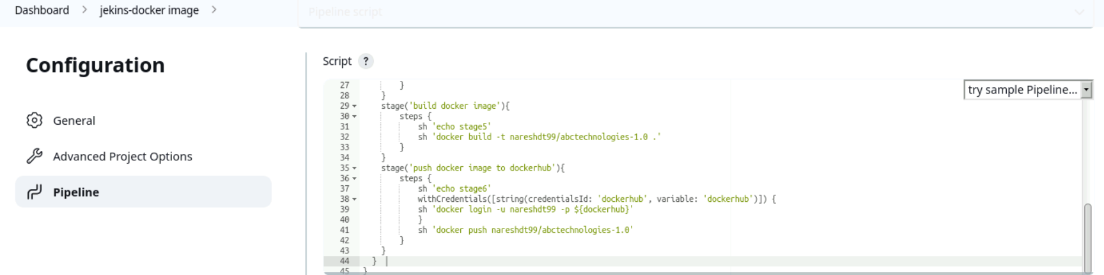

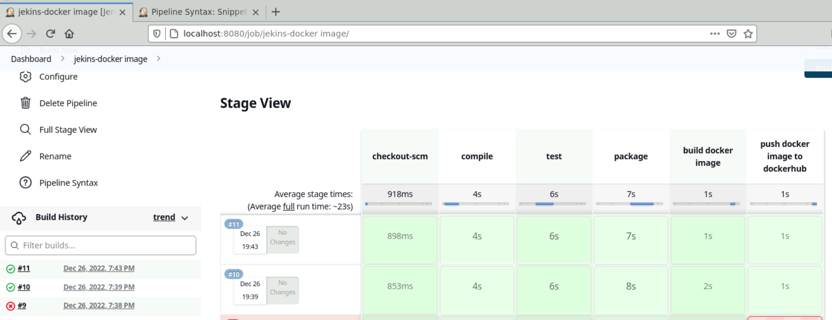

Console output:  
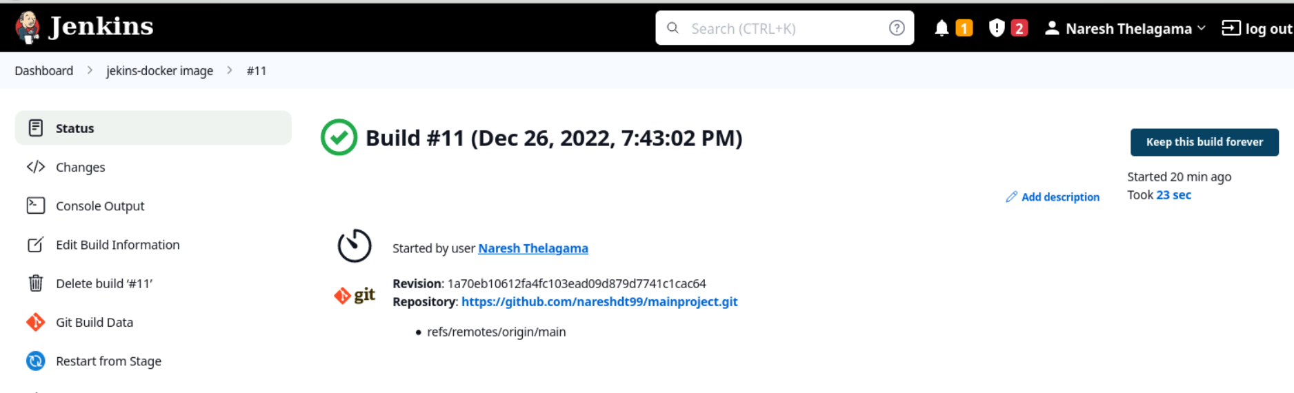

Docker image created:  
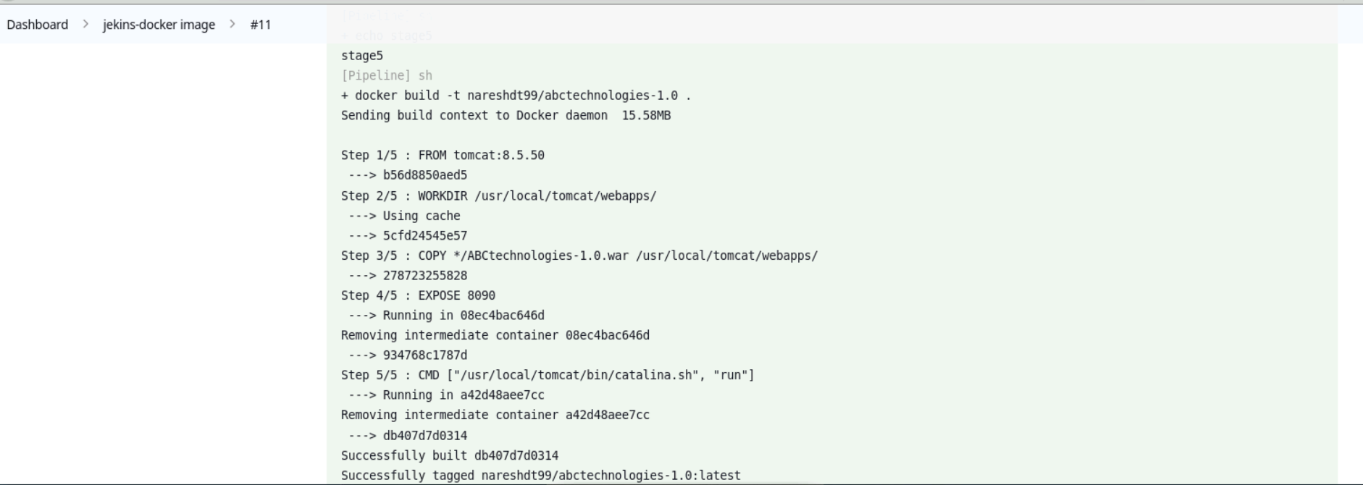

Deploy-on-docker-container Job:  
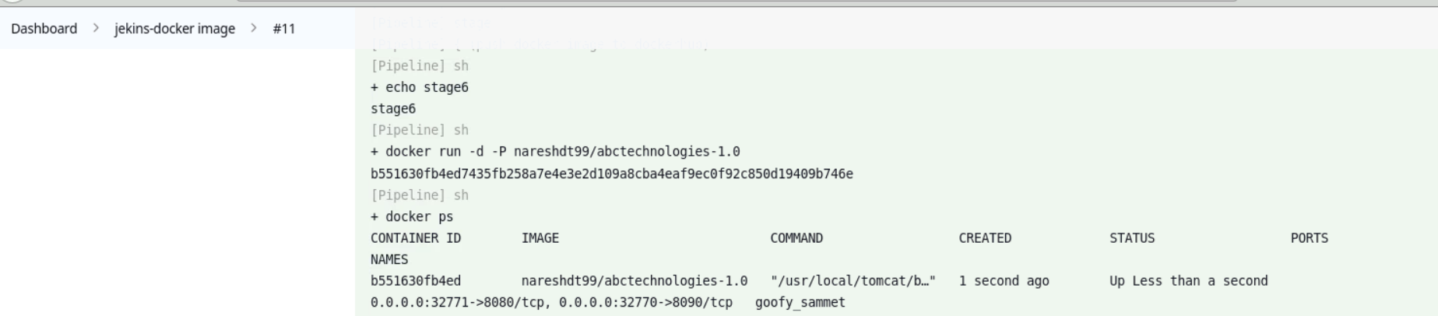

Try on slave VM  
Application Access on Browser: http://localhost:32771/ABCtechnologies-1.0/  
  
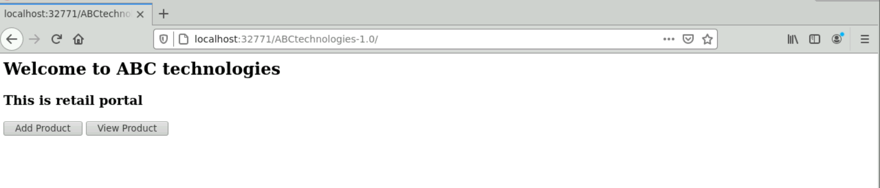  
  
Task 4:   
Integrate the Docker host with Ansible. Write an Ansible playbook to create an image and create a continuer. Integrate Ansible with Jenkins. Deploy Ansible-playbook. CI/CD job to build code on ansible and deploy it on docker container

4.1 Ansible playbook to create an image and create container:  
   
GitHub link:https://github.com/nareshdt99/mainproject/blob/main/ansible-docker.yml   
  
ansible-docker.yml:   
---

- name: Build docker image & deploy on docker container

  gather_facts: true

  hosts: all

  tasks:

    - name: Build the image on local

      docker_image:

       name: nareshdt99/abctechnologies-1.0

       source: build

       build:

        path: .

       tag: latest

    - name: Log into DockerHub

      docker_login:

       username: nareshdt99

       password: $(dockerhub)

       email: nareshdt99@gmail.com

    - name: Tag and push to docker hub on local

      docker_image:

       name: nareshdt99/abctechnologies-1.0

       repository: nareshdt99/abctechnologies-1.0

       push: yes

       source: local

    - name: Remove image

      ignore_errors: yes

      docker_image:

       state: absent

       name: nareshdt99/abctechnologies-1.0

       tag: latest

    - name: Log into DockerHub

      docker_login:

       username: nareshdt99

       password: $(dockerhub)

       email: nareshdt99@gmail.com

    - name: Pull image from dockerhub repo

      docker_image:

       name: nareshdt99/abctechnologies-1.0

       source: pull

    - name: Create the container

      docker_container:

       name: abctechnologies

       image: nareshdt99/abctechnologies-1.0

       ports:

        - "80:8080"

Console Output:

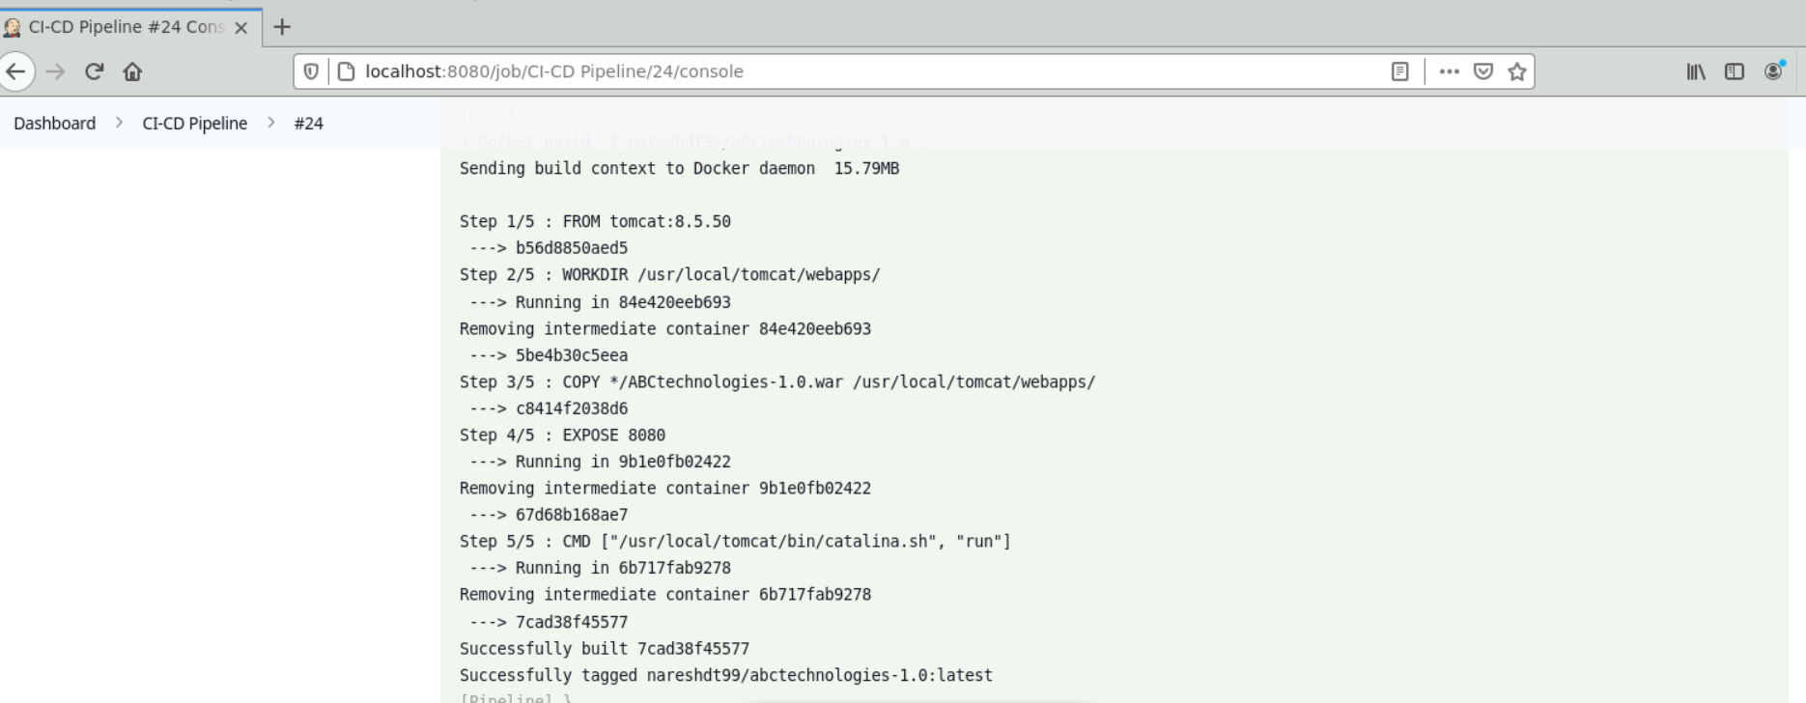

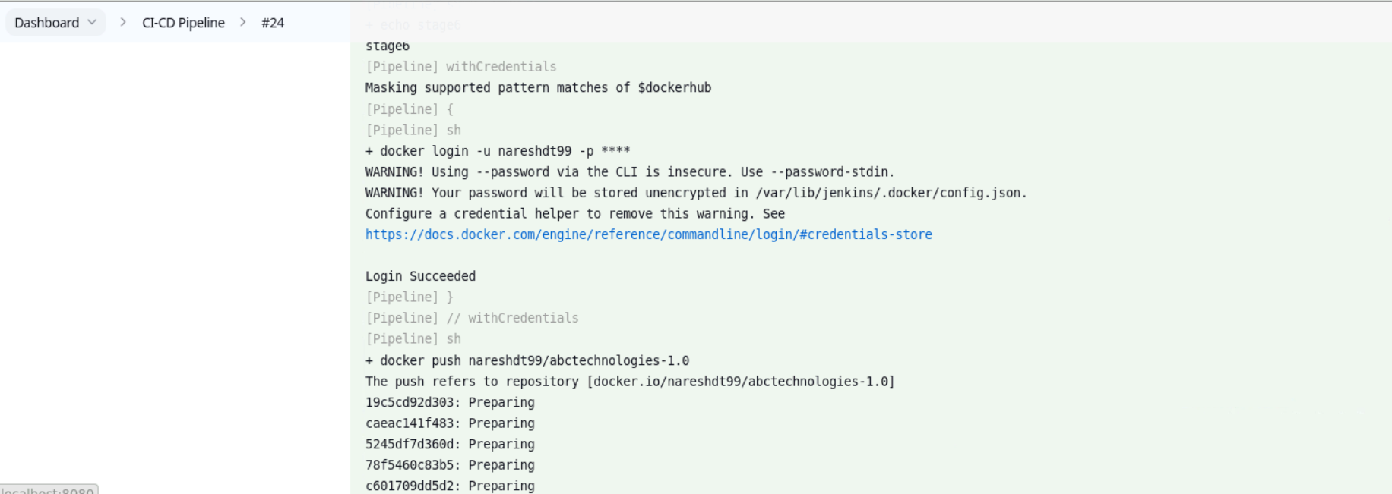

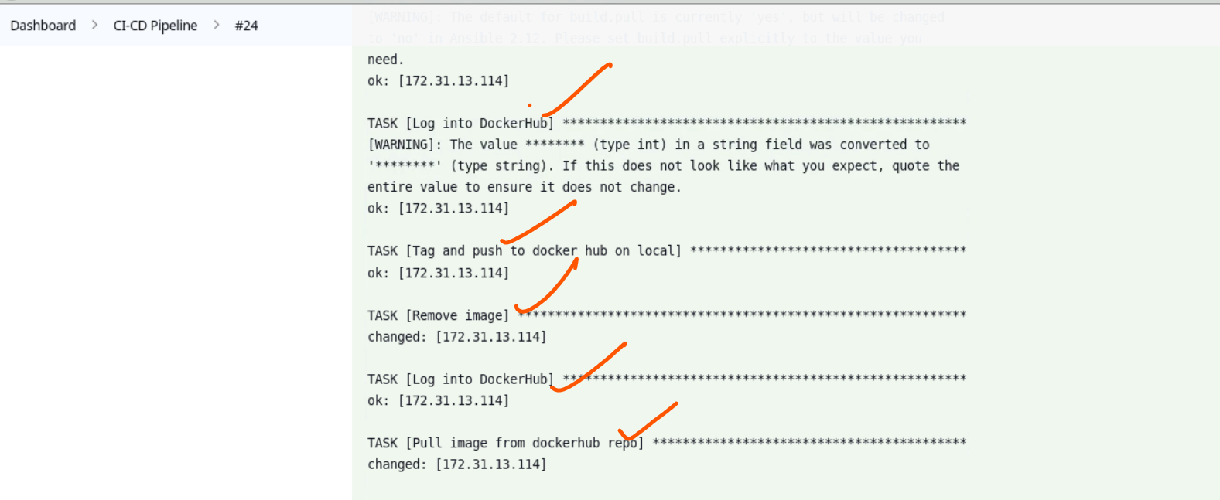

Docker image is built successfully using ansible playbook and moved to docker hub  
Docker hub image: docker pull nareshdt99/abctechnologies-1.0:latest  
  
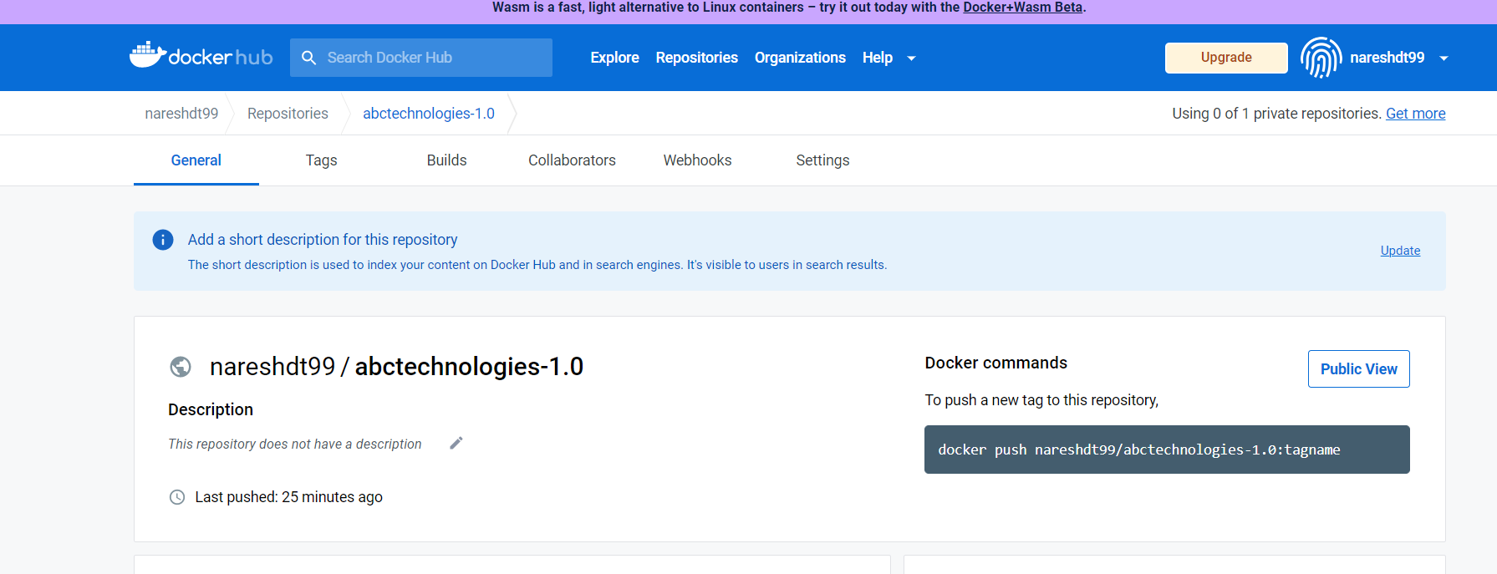  
  
**4.2 writing Kubernetes manifest file for creating pods, deployment and services**

S3 bucket Link: <https://kubernetes-deploy.s3.ap-south-1.amazonaws.com/kube-deployment.yml>

GitHub link: <https://github.com/nareshdt99/mainproject/blob/main/kube-deployment.yml>  
  
 kube-deployment .yml:

apiVersion: apps/v1

kind: Deployment

metadata:

  name: kubeserve

  labels:

    app: kubeserve

spec:

  replicas: 10

  minReadySeconds: 45 # wait for 10 sec before pod is ready going to next

  strategy:

    type: RollingUpdate

    rollingUpdate:

      maxUnavailable: 1  # take down 1 pod at a time

      maxSurge: 2        # bring one at a time

  selector:

    matchLabels:

      app: kubeserve

  template:

    metadata:

      name: kubeserve

      labels:

        app: kubeserve

    spec:

      containers:

      - image: nareshdt99/abctechnologies-1.0

        name: app

---

kind: Service

apiVersion: v1

metadata:

   name: kubeserve-svc

spec:

  type: NodePort

  selector:

    app: kubeserve

  ports:

    - port: 8080

      targetPort: 8080

4.3 integrating ansible with Kubernetes:

---

- name: kubernetes.yml

  gather_facts: true

  hosts: all

  tasks:   
- name: kubernetes Deployment

      become: yes

      command: kubectl apply -f <https://kubernetes-deploy.s3.ap-south-1.amazonaws.com/kube-deployment.yml>

      ignore_errors: true

      args:

        chdir: $HOME

**4.4. Ansible playbook to create Kubernetes deployment and service:**

GitHub link:

---

- name: Build docker image & deploy on docker container

  gather_facts: true

  hosts: all

  tasks:

    - name: Build the image on local

      docker_image:

       name: nareshdt99/abctechnologies-1.0

       source: build

       build:

        path: .

       tag: latest

    - name: Log into DockerHub

      docker_login:

       username: nareshdt99

       password: $(Dockerhub)

       email: [nareshdt99@gmail.com](mailto:nareshdt99@gmail.com)

    - name: Tag and push to docker hub on local

      docker_image:

       name: nareshdt99/abctechnologies-1.0

       repository: nareshdt99/abctechnologies-1.0

       push: yes

       source: local

    - name: Remove image

      ignore_errors: yes

      docker_image:

       state: absent

       name: nareshdt99/abctechnologies-1.0

       tag: latest

    - name: Log into DockerHub

      docker_login:

       username: nareshdt99

       password: $(Dockerhub)

       email: [nareshdt99@gmail.com](mailto:nareshdt99@gmail.com)

    - name: Pull image from dockerhub repo

      docker_image:

       name: nareshdt99/abctechnologies-1.0

       source: pull

    - name: Create the container

      docker_container:

       name: abctechnologies

       image: nareshdt99/abctechnologies-1.0

       ports:

        - "80:8080"

    - name: kubernetes Deployment

      become: yes

      command: kubectl apply -f <https://kubernetes-deploy.s3.ap-south-1.amazonaws.com/kube-deployment.yml>

      ignore_errors: true

      args:

        chdir: $HOME

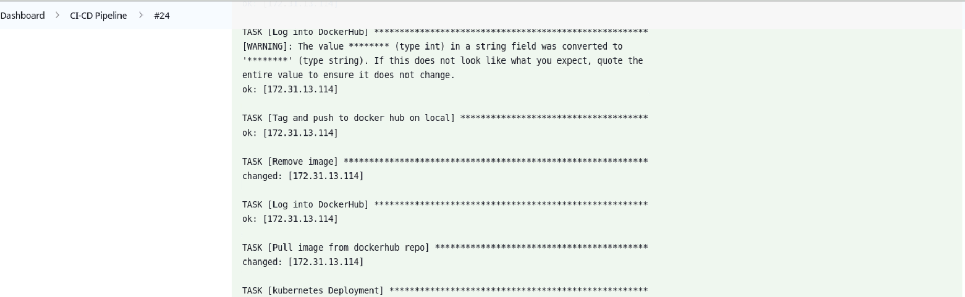

**Complete Jenkins CI/CD pipeline on console:**

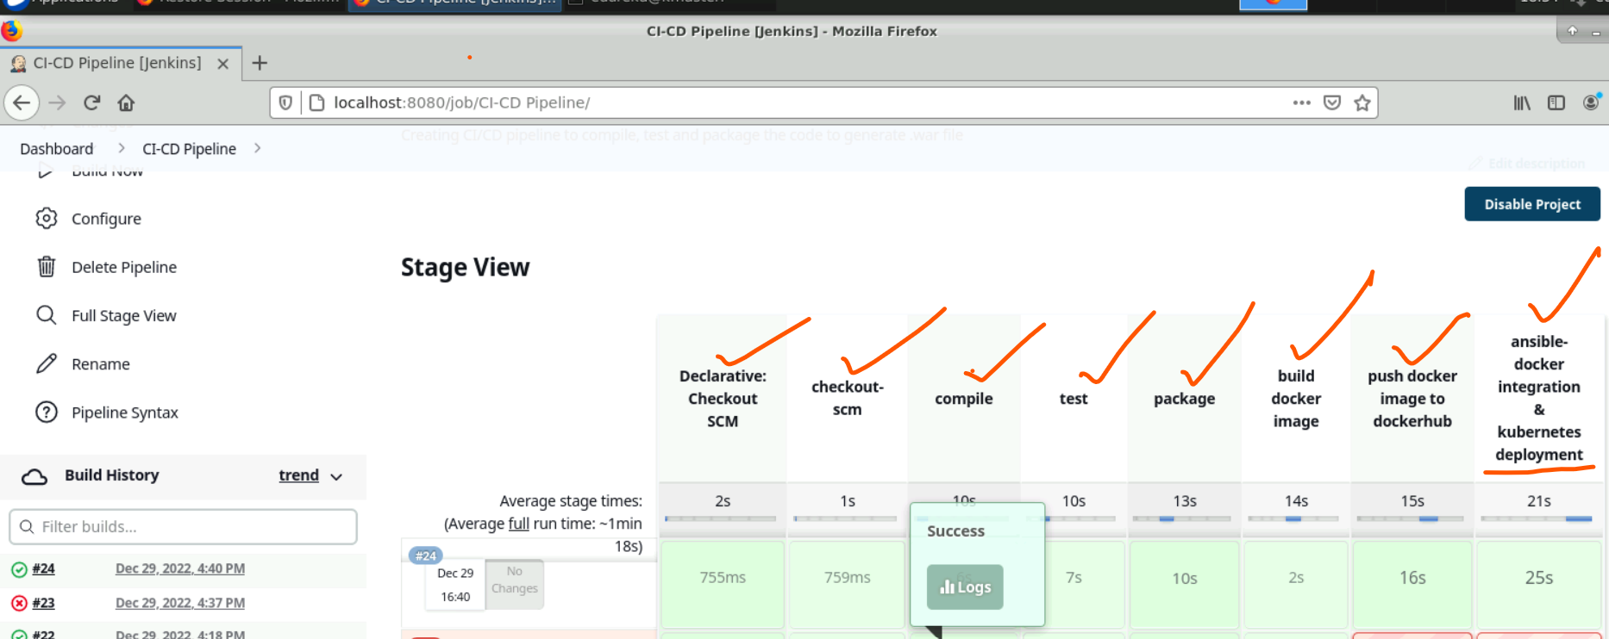

Output:  
command: kubectl get nodes

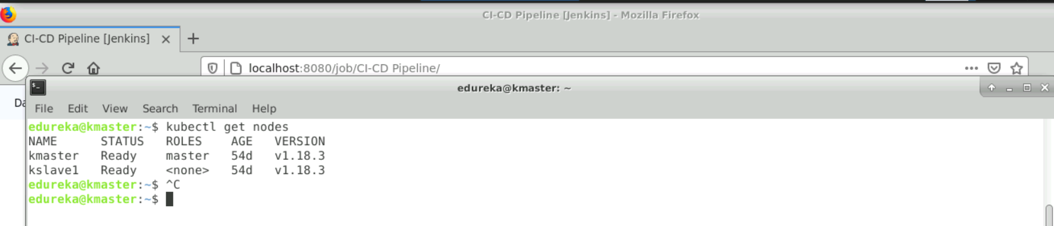

Command: kubectl get pods  
All the pods are running as shown in the screenshot below.

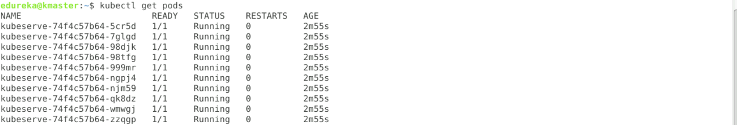

command: kubectl get deployment &&kubectl get service

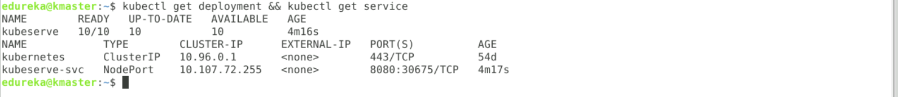

**Accessing application from browser:**

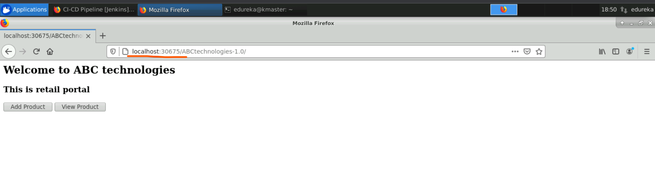Task 5:  
 Using Prometheus, monitor the resources like CPU utilisation: Total Usage, Usage per core, usage breakdown, memory, and network on the instance by providing the endpoints on the local host. Install the node exporter and add the URL to the target in Prometheus. Using this data, log in to Grafana and create a dashboard to show the metrics.

Tainted master node to running pods.

Command: kubectl taint node kmaster node-role.kubernetes.io/master:NoSchedule-

Now services are running on master and slave nodes both.

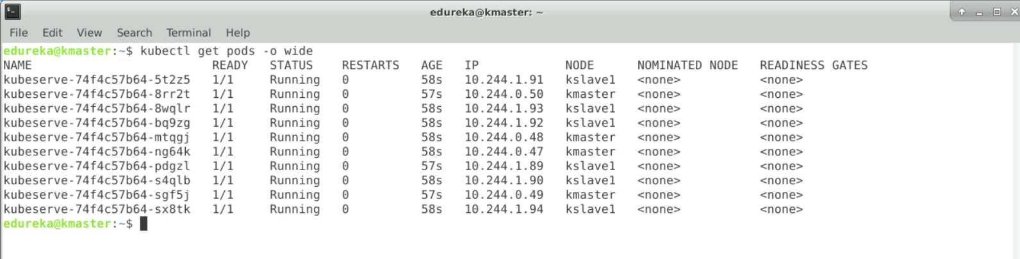

**1.Prometheus is running on the master node at 9090 port:**

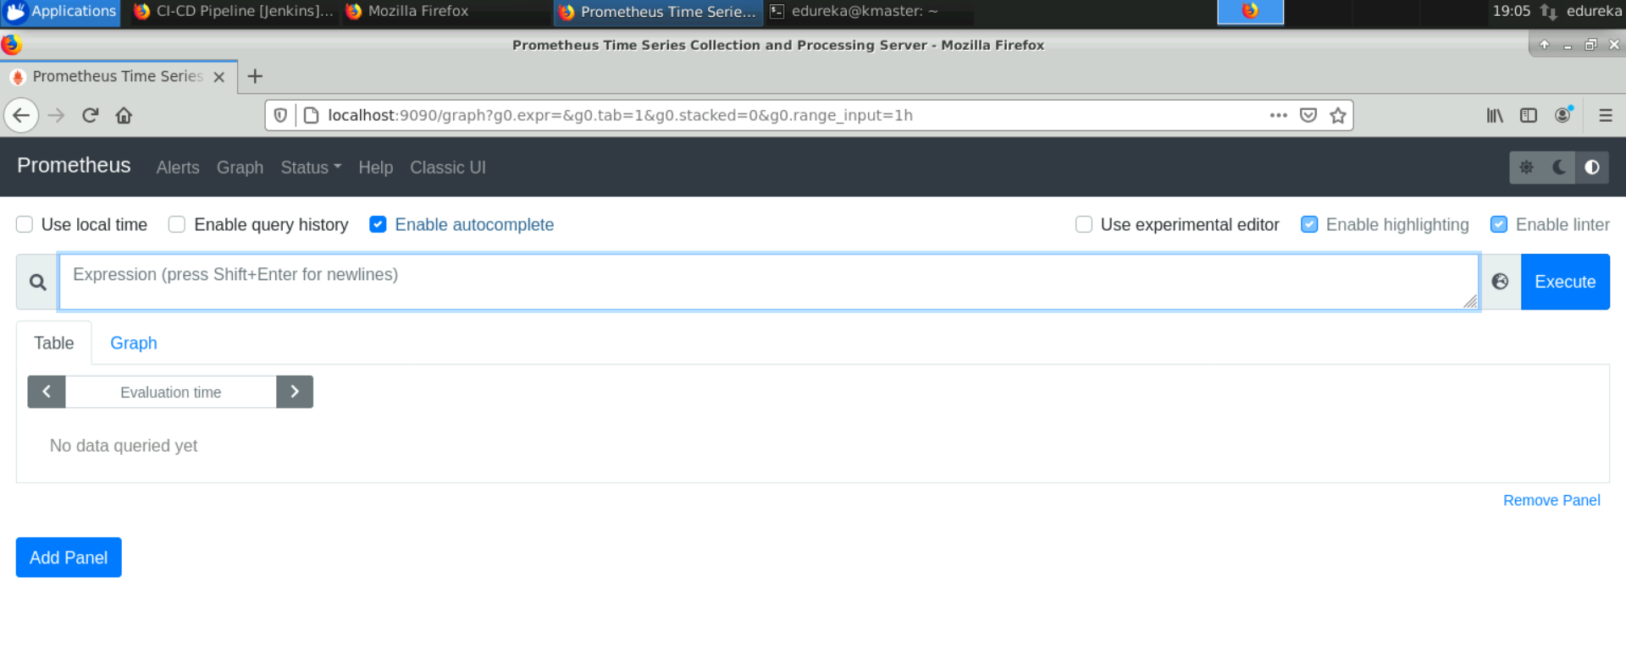

**2. Grafana is running on the master node at 3000 port:**

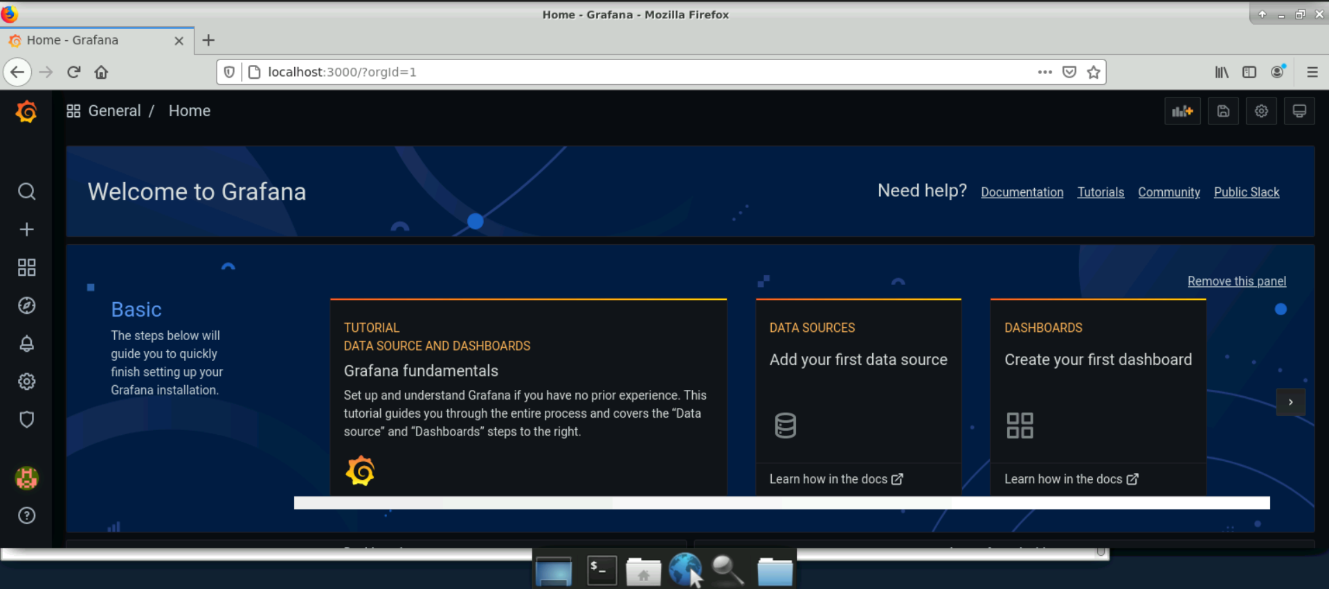

Adding Prometheus to Grafana as Data source

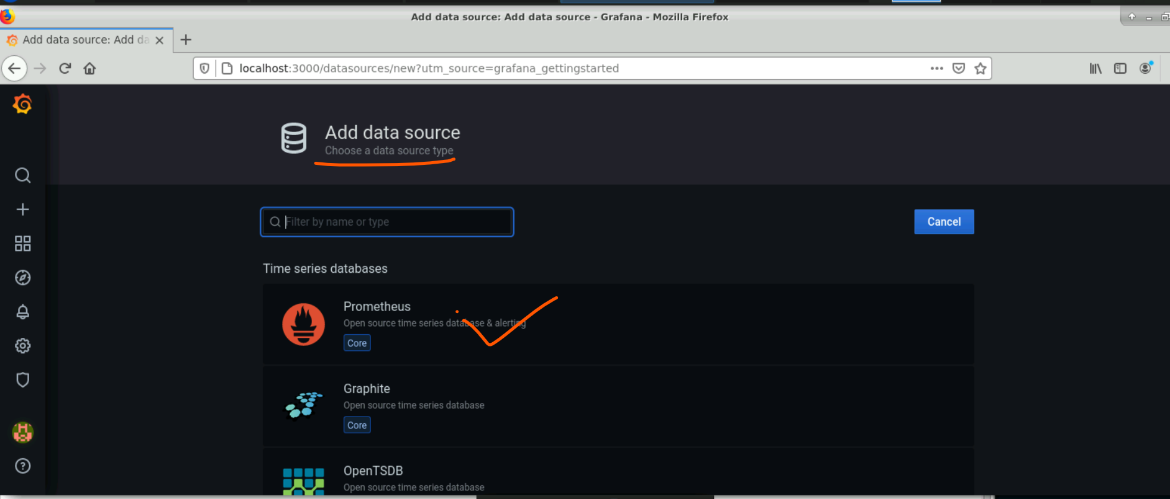

**3.** **Installing NodeExporter on slave machine:**  
  
sudo wget <https://github.com/prometheus/node_exporter/releases/download/v1.3.1/node_exporter-1.3.1.linux-amd64.tar.gz>

sudo tar xf node_exporter-1.3.1.linux-amd64.tar.gz  
cd node_exporter-1.3.1.linux-amd64  
./node_exporter  
Node exporter is running at 9100 port on slave machine.

url: http://localhost:9100/metrics

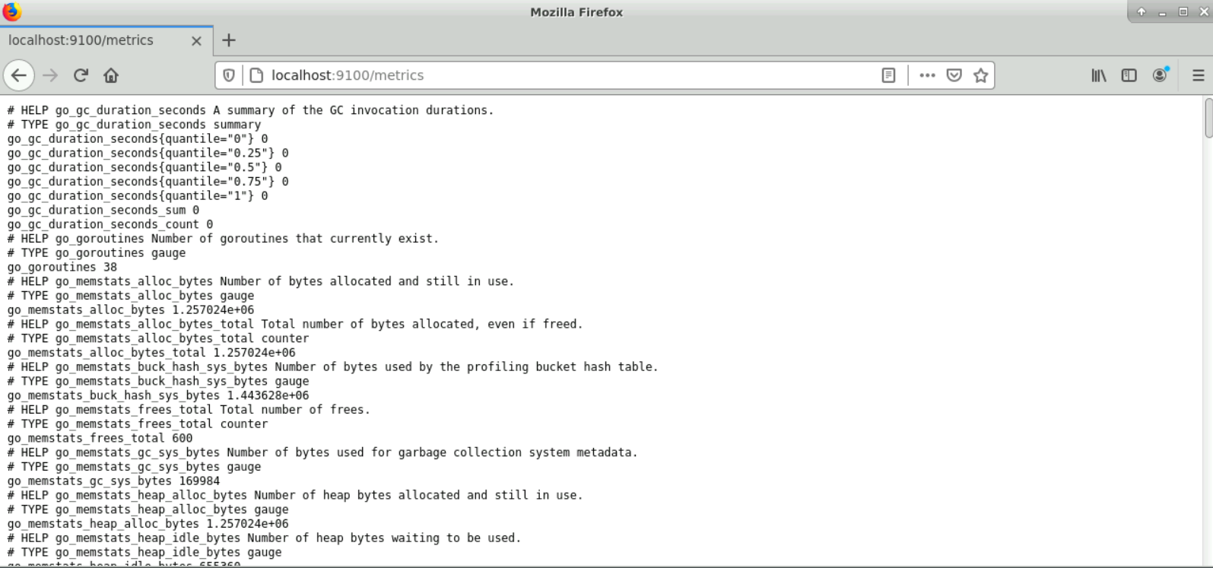  
  
4. Add slave machine as target in Prometheus target (Prometheus.yml) and restart Prometheus service

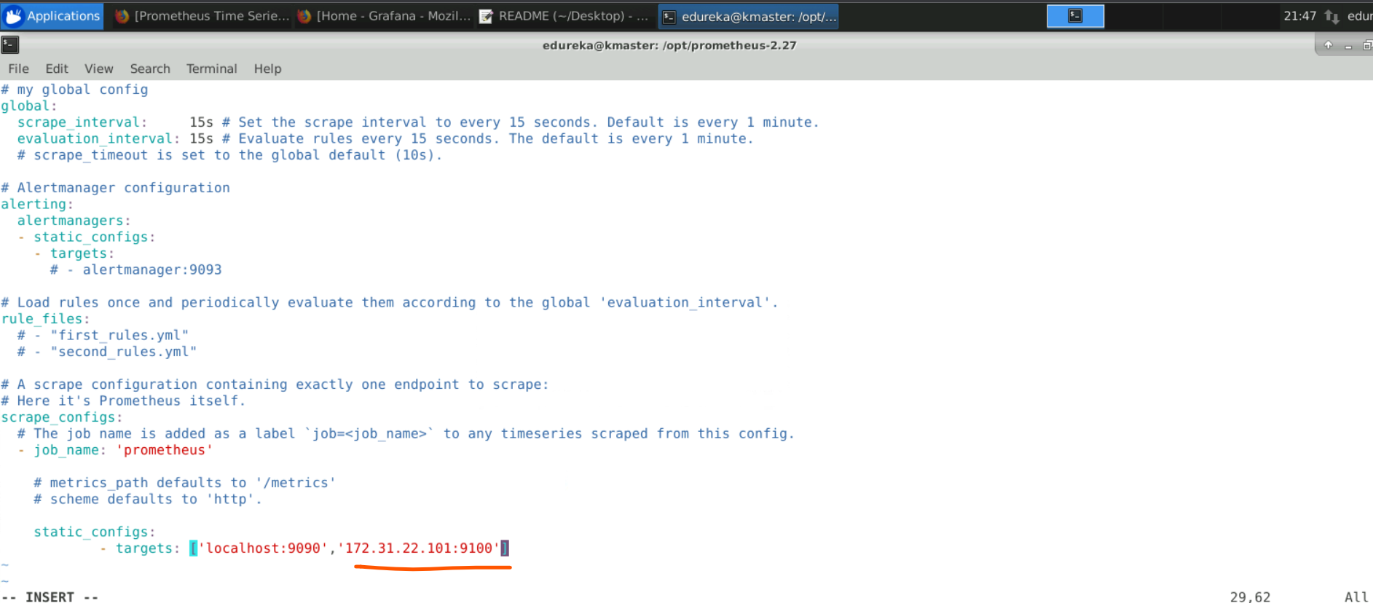

Sudo ./prometheus

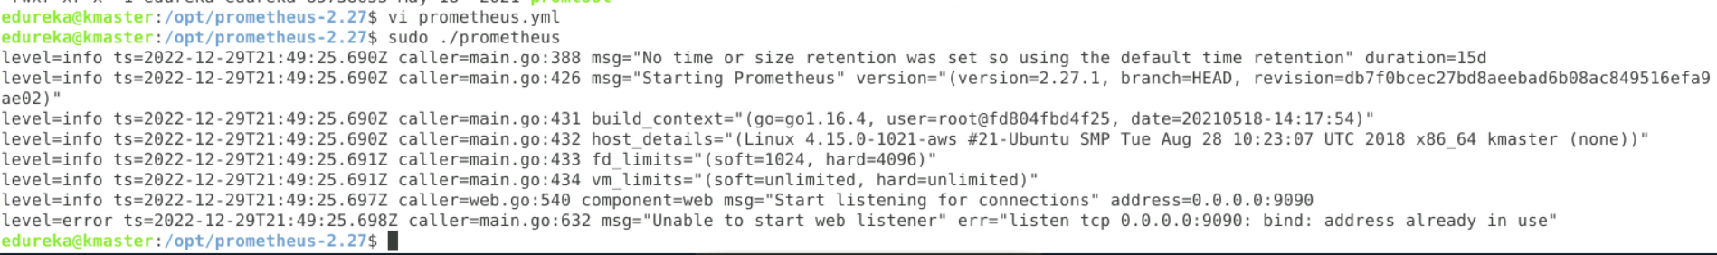

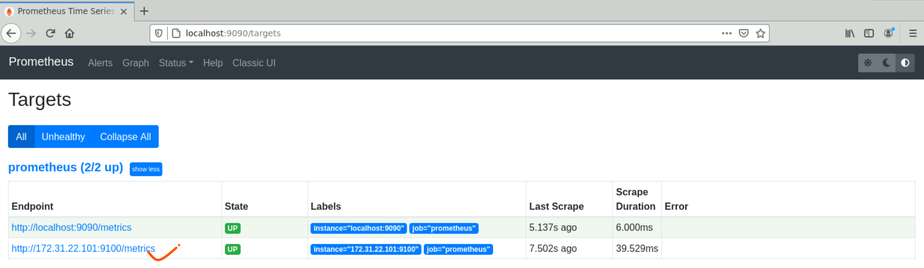

5. Import dashboard on Grafana: used 10204 templates

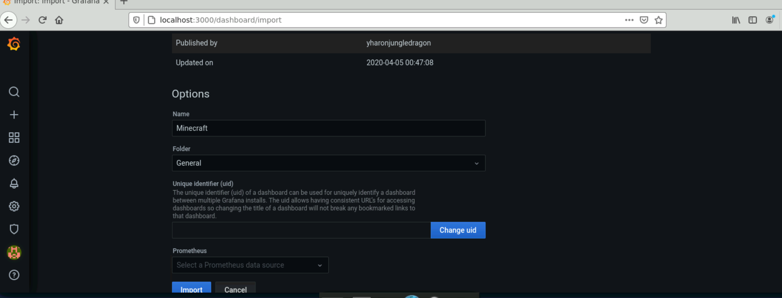

**Monitoring using Prometheus:**  
Total Cpu utilisation:   
100 - (avg by(instance) (irate(node_cpu{mode="idle", instance="172.31.22.101:9100"}[5m])) * 100)  
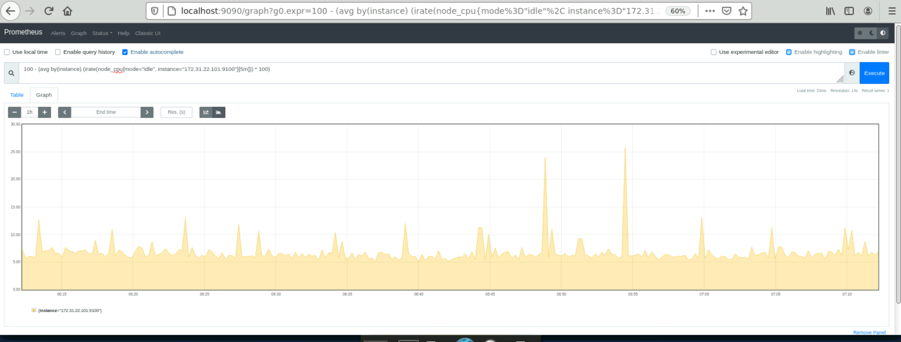

Node memory per core:

node_memory_Percpu{instance="172.31.22.101:9100", job="prometheus"}

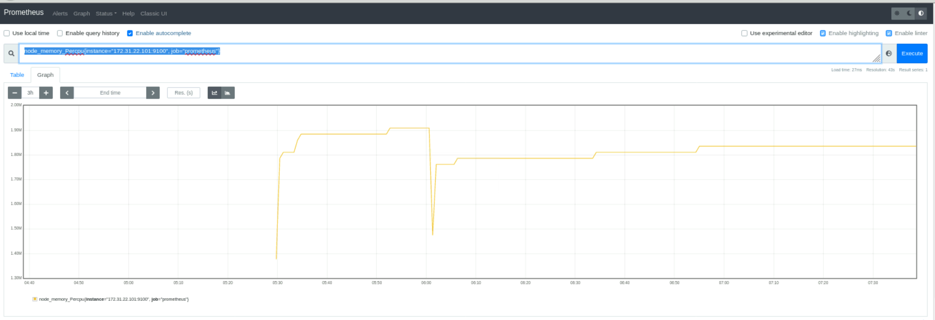

Memory Available:  
node_memory_MemAvailable{instance="172.31.22.101:9100", job="prometheus"} / node_memory_MemTotal{instance="172.31.22.101:9100", job="prometheus"} * 100  
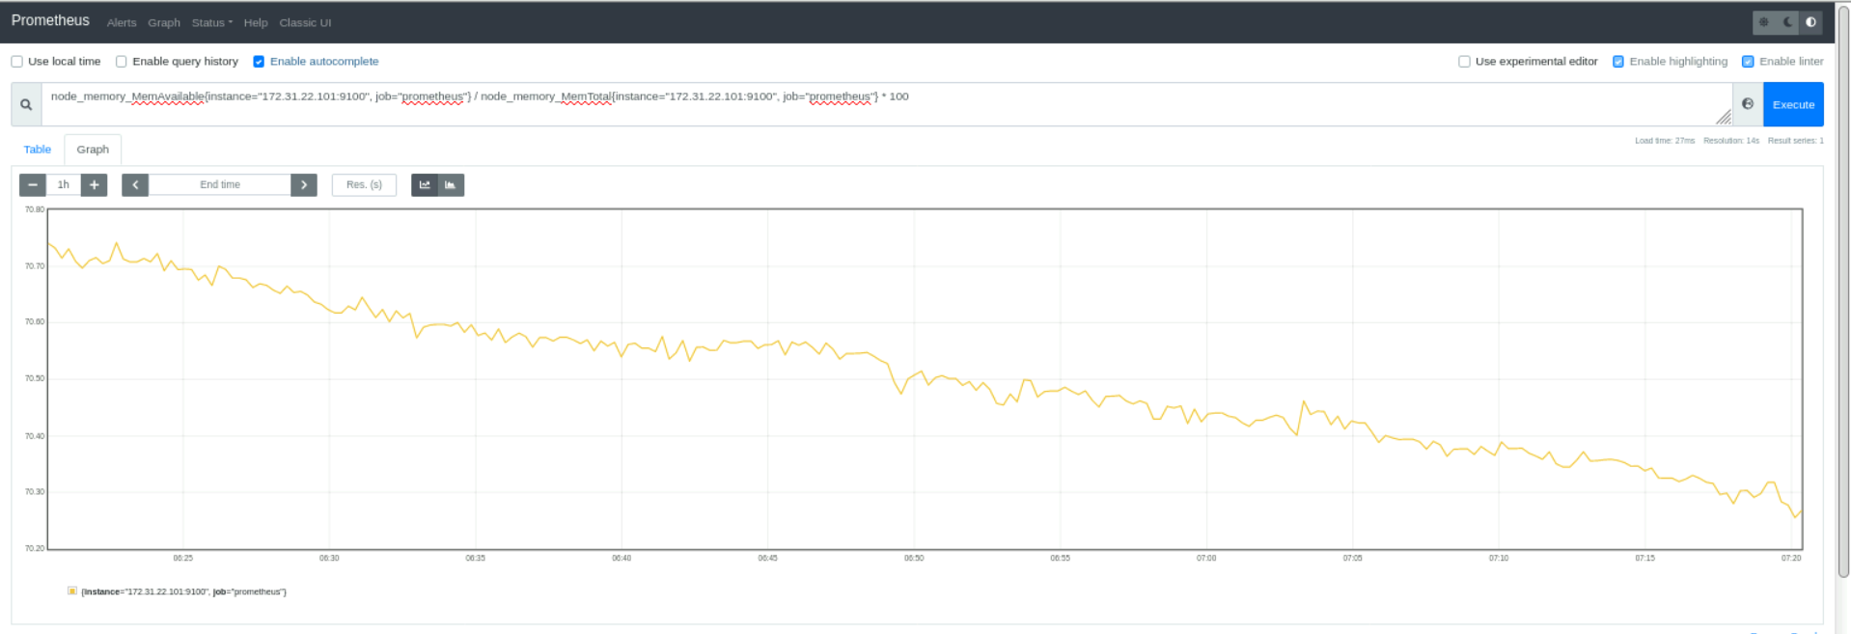

Network:  
node_network_receive_bytes{device="cni0", instance="172.31.22.101:9100", job="prometheus"}  
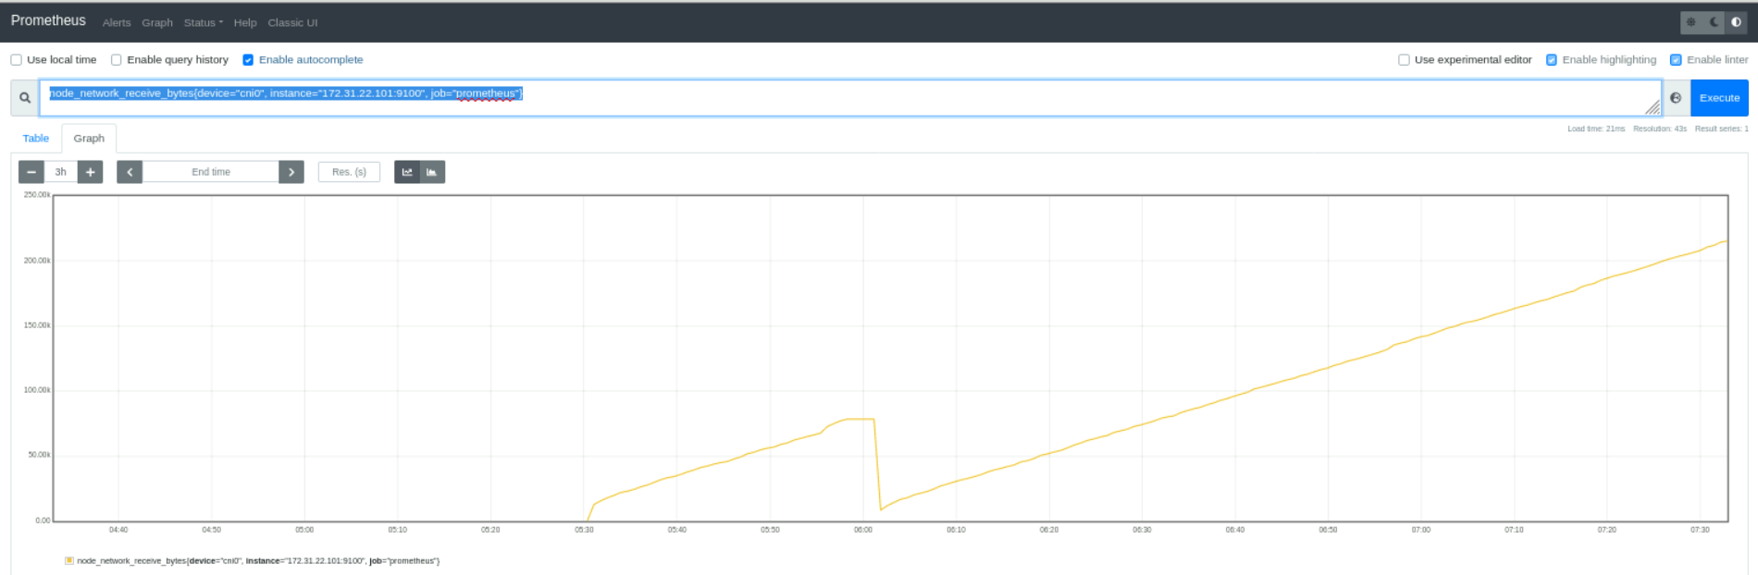  
  
  
  
  
  
  
**Monitoring using Grafana:**  
Cpu Utilisation monitoring using Grafana

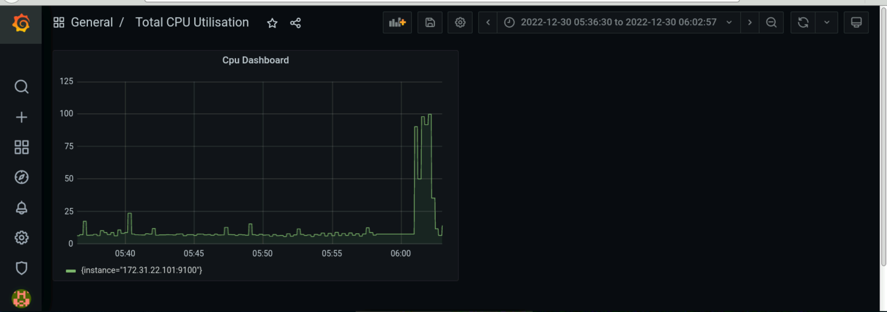  
  
memory utilistation:

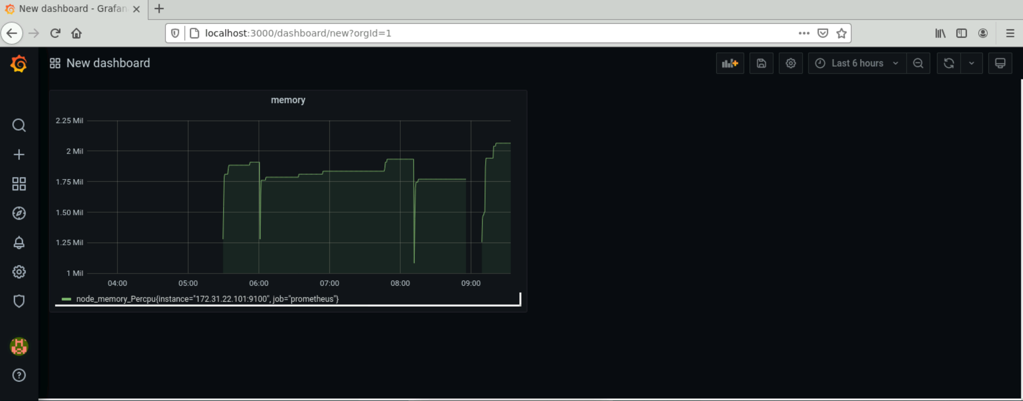

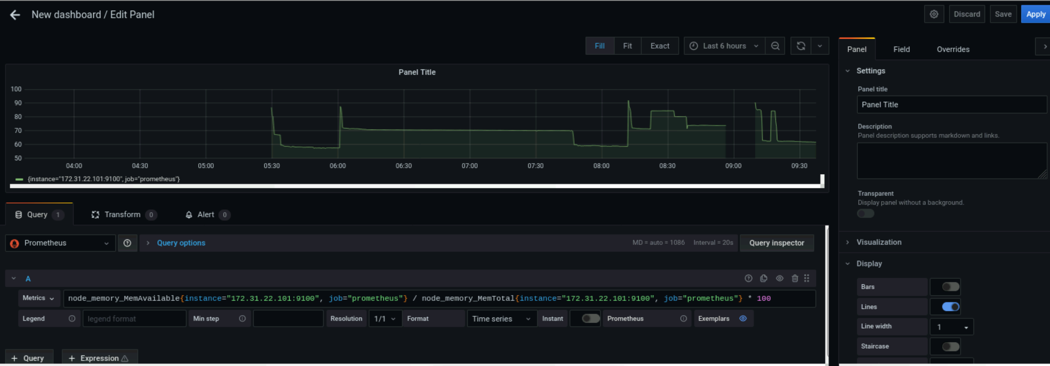

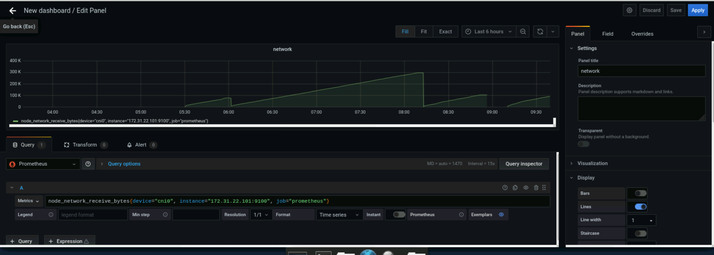

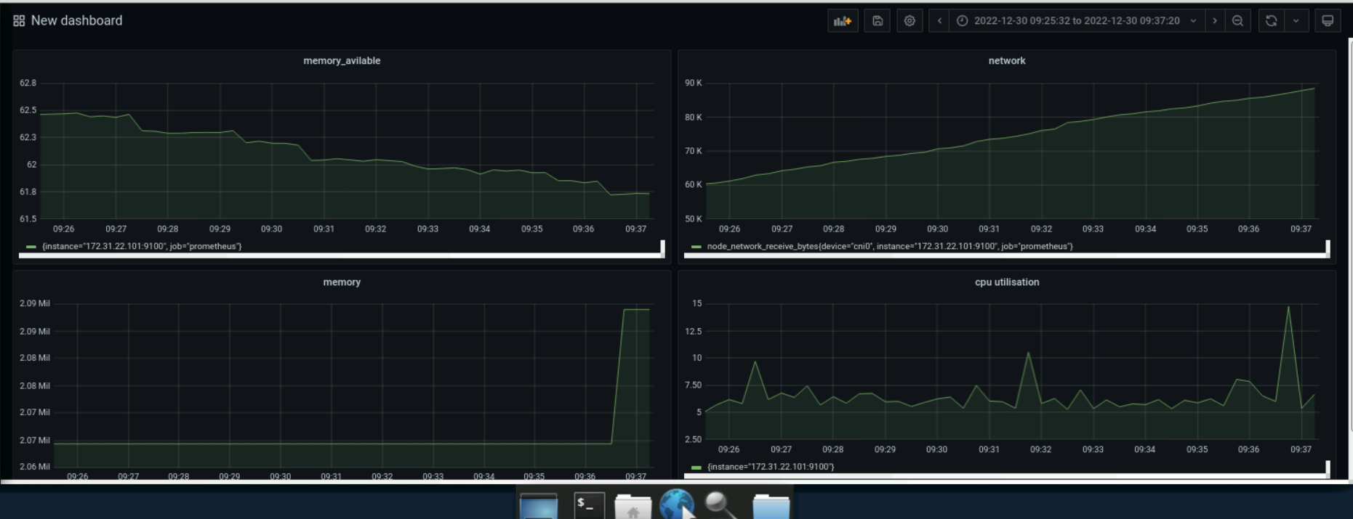  
  
**—---------------------------------- This Step completes the project —--------------------------------------------**  
  
  
  
  
NOTE1: while generating docker image in Jenkins CD/CD pipeline pls run this command in master machine   
 If not pile line may fail.  
 sudo groupadd docker  
 sudo usermod -aG docker ${USER}  
 su -s ${USER}  
 sudo chmod 666 /var/run/docker.sock  
 docker run hello-world  
NOTE2: There is an issue with Github while accessing kube-deploy.yml file to create Kubernetes pods, services  
 So I have used AWS s3 bucket to store kube-deplyment.yml file and placed in GitHub for reference.